**AOI System -Operator Manual**

**Version: 1.2   
 Intended Audience: Operators**

# 

Table of Contents

1. Introduction 1

1.1 Purpose of the AOI System 1

1.2 Intended Users 1

1.3 System Overview 1

1.4 Operator Responsibilities 1

2. Login Screen………………………………………………………………………………………………………………………………….6

**3**.**Operator Responsibility** 7

**4. Safety and Operational Notes** 7

**5.1 Screen Name** 8

**5.2 Purpose** 8

**5.3 Screen Overview** 8

**5.4 Available Control Options** 8

**5.6 System Behavior** 10

**5.7 Operator Guidelines** 11

**5.8 Safety and Operational Notes** 11

**5.9 Operator Note** 11

**6.1 Screen Name** 12

**6.2 Purpose** 12

**6.3 Screen Overview** 12

**6.4 System Behavior** 13

**6.5 Operation Activity Log Update** 13

**6.6 System Conditions** 14

**6.7 Operator Guidelines** 14

**6.8 Safety and Operational Notes** 14

**7.1 Screen Name** 15

**7.2 Purpose** 15

**7.3 Screen Overview** 15

**7.4 System Behavior After Selecting Dry Run** 16

**7.5 Operation Activity Log Update** 16

**7.6 Typical Use Cases** 16

**7.7 Operator Guidelines** 16

**7.8 Safety and Operational Notes** 17

**7.9 Operator Note** 17

**8 Manual Operation Mode** 18

**8.1 Screen Name** 18

**8.2 Purpose** 18

**8.3 Screen Overview** 18

**8.5 System Behavior** 20

**8.6 Operator Guidelines** 21

**8.7 Safety and Operational Notes** 21

**8.8 Operator Note** 21

9 Cycle Stop Operation 22

**9.1 Screen Name** 22

**9.2 Purpose** 22

**9.3 Screen Overview** 22

**9.4 System Behavior After Selecting Cycle Stop** 23

**9.5 Operation Activity Log Update** 23

**9.6 Typical Use Cases** 23

**9.7 Operator Guidelines** 23

**9.8 Safety and Operational Notes** 24

**9.9 Operator Note** 24

**10.1 Screen Name** 25

**10.2 Purpose** 25

**10.3 Screen Overview** 25

**10.4 System Behavior After Selecting Machine Home** 26

**10.5 Operation Activity Log Update** 26

**10.6 Typical Use Cases** 26

**10.7 Operator Guidelines** 26

**10.8 Safety and Operational Notes** 27

**10.9 Operator Note** 27

**11 Home Screen and Navigation Menu** 28

**11.1 Screen Name** 28

**11.2 Purpose** 28

**11.3 Screen Overview** 28

**11.4 Left Navigation Menu** 29

**11.5 System Behavior** 29

**11.6 Operator Guidelines** 30

**11.7 Safety and Operational Notes** 30

**12.1 Screen Name** 31

**12.2 Purpose** 31

**12.3 Screen Overview** 31

**12.4 Displayed Information** 32

**12.5 System Behavior** 32

**12.6 Operator Guidelines** 32

**12.7 Safety and Operational Notes** 33

**12.8 Operator Note** 33

**13.1 Screen Name** 34

**13.2 Purpose** 34

**13.3 Screen Overview** 34

**13.4 Displayed Information** 35

**13.5 System Behavior** 36

**13.6 Operator Guidelines** 36

**13.7 Safety and Operational Notes** 36

**13.8 Operator Note** 36

**14 Downtime Statistics Screen** 37

**14.1 Screen Name** 37

**14.2 Purpose** 37

**14.3 Screen Overview** 37

**14.4 Displayed Information** 38

**14.5 System Behavior** 39

**14.6 Operator Guidelines** 39

**14.7 Safety and Operational Notes** 39

**14.8 Operator Note** 39

**15 Cycle Time Trends Screen** 40

**15.1 Screen Name** 40

**15.2 Purpose** 40

**15.3 Screen Overview** 40

**15.4 Displayed Information** 41

**15.5 System Behavior** 42

**15.6 Operator Guidelines** 42

**15.7 Safety and Operational Notes** 42

**15.8 Operator Note** 42

**16.1 Screen Name** 44

**16.2 Purpose** 44

**16.3 Screen Overview** 44

**16.4 Displayed Information** 45

**16.5 System Behavior** 46

**16.6 Operator Guidelines** 46

**16.7 Safety and Operational Notes** 46

**16.8 Operator Note** 46

**17 Production Quality (OK) Screen** 47

**17.1 Screen Name** 47

**17.2 Purpose** 47

**17.3 Screen Overview** 47

**17.4 Displayed Information** 48

**17.5 System Behavior** 49

**17.6 Operator Guidelines** 49

**17.7 Safety and Operational Notes** 49

**17.8 Operator Note** 49

**18 Rejection Statistics (NG) Screen** 50

**18.1 Screen Name** 50

**18.2 Purpose** 50

**18.3 Screen Overview** 50

**18.4 Displayed Information** 51

**18.5 System Behavior** 52

**18.6 Operator Guidelines** 52

**18.7 Safety and Operational Notes** 52

**18.8 Operator Note** 52

**19.1 Screen Name** 53

**19.2 Purpose** 53

**19.3 Screen Overview** 53

**19.4 Displayed Information** 54

**19.5 System Behavior** 55

**19.6 Operator Guidelines** 55

**19.7 Safety and Operational Notes** 55

**19.8 Operator Note** 55

**20 OEE Score Statistics Screen** 56

**20.1 Screen Name** 56

**20.2 Purpose** 56

**20.3 Screen Overview** 56

**20.4 Displayed Information** 56

**20.5 System Behavior** 57

**20.6 Operator Guidelines** 57

**20.7 Safety and Operational Notes** 57

**20.8 Operator Note** 57

**21 PLC I/O Monitor Screen** 58

**21.2 Purpose** 58

**21.3 Screen Overview** 58

**21.4 Screen Layout Description** 59

**21.5 System Behavior** 60

**21.6 Operator Guidelines** 60

**21.7 Safety and Operational Notes** 60

**21.8 Operator Note** 60

**22 Alarm View Screen** 61

**22.1 Screen Name** 61

**22.2 Purpose** 61

**22.3 Screen Overview** 61

**22.4 Screen Layout Description** 62

**22.5 System Behavior** 63

**22.6 Operator Guidelines** 63

**22.7 Safety and Operational Notes** 63

**22.8 Operator Note** 63

**23 Startup Conditions Screen** 64

**23.1 Screen Name** 64

**23.2 Purpose** 64

**23.3 Screen Overview** 64

**23.4 Displayed Information** 65

**23.5 System Behavior** 65

**23.6 Operator Guidelines** 66

**23.7 Safety and Operational Notes** 66

**23.8 Operator Note** 66

**24.1 Screen Name** 67

**24.2 Purpose** 67

**24.3 Screen Overview** 67

**24.4 Log Categories** 68

**24.5 System Behavior** 69

**24.6 Operator Guidelines** 69

**24.7 Safety and Operational Notes** 69

**24.8 Operator Note** 69

**25 Audit Logs Screen** 71

**25.1 Screen Name** 71

**25.2 Purpose** 71

**25.3 Screen Overview** 71

**25.4 File List Panel** 72

**25.5 File Content View Panel** 72

**25.6 Logged Activities** 73

**25.7 System Behavior** 73

**25.8 Operator Guidelines** 73

**25.9 Administrator Notes** 73

**25.10 Important Notes** 73

**26 Error Logs Screen** 74

**26.1 Screen Name** 74

**26.2 Purpose** 74

**26.3 Screen Overview** 74

**26.4 File List Panel** 75

**26.5 File Content View Panel** 75

**26.6 Typical Error Entries** 76

**26.7 System Behavior** 76

**26.8 Operator Guidelines** 76

**26.9 Administrator Notes** 76

**26.10 Important Notes** 76

**27 Diagnostics Logs Screen** 77

**27.1 Screen Name** 77

**27.2 Purpose** 77

**27.3 Screen Overview** 77

**27.4 Diagnostics File List Panel** 78

**27.5 File Content View Panel** 78

**27.6 Typical Diagnostic Events** 79

**27.7 System Behavior** 79

**27.8 Operator Guidelines** 79

**27.9 Administrator Notes** 79

**27.10 Important Notes** 80

**28 Reports Module** 81

**28.1 Screen Name** 81

**28.2 Purpose** 81

**28.3 Screen Overview** 81

**28.4 Production Data** 82

**28.4.1 Screen Name** 82

**28.4.2 Purpose** 82

**28.4.3 Screen Overview** 82

**28.4.4 Displayed Information** 82

**28.4.5 Operator Guidelines** 83

**28.6 Production Images** 83

**28.6.1 Screen Name** 83

**28.6.2 Purpose** 83

**28.6.3 Screen Overview** 83

**28.6.4 Displayed Information** 84

**28.6.5 Operator Guidelines** 84

**28.7 Report Behavior** 84

**29.1 Screen Name** 85

**29.2 Purpose** 85

**29.3 Screen Overview** 85

**29.4 Available Configuration Menu Options** 86

**29.4.1 Log Config** 86

**29.4.2 Device Config** 86

**29.4.3 Alarm Config** 86

**29.4.4 User Config** 86

**29.4.5 PLC TAG Config** 87

**29.4.6 Shift Config** 87

**29.4.7 Report Config** 87

**29.4.8 Servo Parameters** 87

**29.4.9 Time Sync** 87

**29.4.10 Diagnostic** 87

**29.4.11 External Interface** 87

**29.4.12 MacMini Test** 87

**29.5 Important Notes** 87

**30.1 Screen Name** 88

**30.2 Purpose** 88

**30.3 Screen Overview** 88

**30.4 Log Configuration Table Description** 89

30.5 Available Log Types 89

**30.6 Operator / Administrator Guidelines** 90

**30.7 Important Notes** 90

**31 Device Configuration** 91

**31.1 Screen Name** 91

**31.2 Purpose** 91

**31.3 Screen Overview** 91

**31.4 Device Configuration Table Description** 92

**31.5 Add Device Function** 93

**31.6 Operator / Administrator Guidelines** 93

**31.7 Important Notes** 93

**32 Alarm Configuration** 94

**32.1 Screen Name** 94

**32.2 Purpose** 94

**32.3 Screen Overview** 94

**32.4 Alarm Configuration Table Description** 95

**32.5 Filter Function** 96

**32.6 Add Alarm Function** 96

**32.7 Operator / Administrator Guidelines** 96

**32.8 Important Notes** 97

**33 User Configuration (User Management)** 98

**33.1 Screen Name** 98

**33.2 Purpose** 98

**33.3 Screen Overview** 98

**33.4 User List Table Description** 98

**33.5 Search User Function** 99

**33.6 Add User Function** 99

**33.7 Operator / Administrator Guidelines** 100

**33.8 Important Notes** 100

**34 PLC Tag Configuration** 101

**34.1 Screen Name** 101

**34.2 Purpose** 101

**34.3 Screen Overview** 101

**34.4 PLC Tag List Table Description** 102

**34.5 Search Function** 103

**34.6 Add Tag Function** 103

**34.6 Add Tag Function** 103

**34.8 Important Notes** 103

**35 Shift Configuration** 104

**35.1 Screen Name** 104

**35.2 Purpose** 104

**35.3 Screen Overview** 104

**35.4 Shift List Table Description** 105

**35.5 Shift Details Panel** 105

**35.5 Shift Details Panel** 105

**35.7 Important Notes** 106

**36 Report Configuration** 107

**36.1 Screen Name** 107

**36.2 Purpose** 107

**36.3 Screen Overview** 107

**36.4 Saved Report Formats Section** 108

**36.5 Report Details Section** 108

**36.6 Selected Columns Section** 109

**36.7 Action Buttons** 109

**36.8 Operator / Administrator Guidelines** 109

**36.9 Important Notes** 109

**37 Servo Parameters** 110

**37.1 Screen Name** 110

**37.2 Purpose** 110

**37.3 Screen Overview** 110

**37.4 X-Axis Parameters** 111

**37.5 Y-Axis Parameters** 112

**37.6 Parameter Update Procedure** 112

**37.7 Operator Actions** 112

**37.8 Operator Guidelines** 113

**37.9 Important Notes** 113

**38. Set Coords (Position Teaching)** 113

**38.1 Screen Name** 113

**38.2 Purpose** 113

**38.3 Screen Overview** 113

**38.4 Displayed Information** 114

**38.5 Operator Actions** 114

**38.6 Jog Controls** 115

**38.7 Teaching Procedure** 115

**38.8 Operator Guidelines** 115

**38.9 Important Notes** 115

**39 Time Sync (System Synchronization)** 116

**39.1 Screen Name** 116

**39.2 Purpose** 116

**39.3 Screen Overview** 116

**39.4 Displayed Information** 117

**39.5 Operator Actions** 117

**39.6 Synchronization Process** 117

**39.7 Operator Guidelines** 117

**39.8 Important Notes** 118

**40.1 Screen Name** 119

**40.2 Purpose** 119

**40.3 Screen Overview** 119

**40.4 Displayed Information** 120

**40.5 Operator Actions** 120

**40.6 Usage Guidelines** 120

**40.7 Operator Access Control** 120

**40.8 Important Notes** 121

**41.1 Screen Name** 122

**41.2 Purpose** 122

**41.3 Screen Overview** 122

**41.4 Input Fields Description** 123

**41.5 Response Panel** 123

**41.6 Operator Actions** 123

**41.7 Usage Guidelines** 123

**41.8 Operator Access Control** 124

**41.9 Important Notes** 124

# **1. Introduction**

The **AOI System (Automated Optical Inspection System)** is an industrial inspection application designed to **automatically monitor, inspect, and evaluate product quality** during the production process.

The system integrates with **machine vision cameras, PLC controllers, and industrial hardware** to perform real-time inspection and collect production data. It helps Operators and Supervisors ensure that every product meets defined quality standards before moving to the next process stage.

The AOI System provides a centralized platform to:

* Monitor inspection performance
* Track production and quality statistics
* Detect and display alarms and system faults
* Maintain system and production logs
* Generate reports for analysis and traceability

This application is primarily intended for **shop-floor Operators** who are responsible for running and monitoring the inspection process.

# **1.1 Purpose of the AOI System**

The main purpose of the AOI System is to:

* Detect product defects automatically using vision-based inspection
* Reduce manual inspection effort and human error
* Improve production efficiency and consistency
* Provide accurate and traceable production records
* Support continuous quality improvement

By using automated inspection, the system ensures **higher accuracy, faster inspection cycles, and reliable quality control** compared to manual method

# **Intended Users**

This Operator Manual is prepared for the following users:

**Operators:**  
Responsible for daily operation, monitoring, and basic control of the AOI System.

* **Supervisors / Quality Staff (View Only):**  
  May use reports and logs for performance analysis and quality tracking.

System configuration and advanced settings are handled by **authorized administrative users** and are not part of routine operator activities.

# **1.3 System Overview**

The AOI System consists of the following main functional areas:

1. **Login and User Authentication**  
   Ensures only authorized users can access the system.
2. **Dashboard and OEE Monitoring**  
   Displays real-time inspection performance, production counts, efficiency, and machine status.
3. **Alarm Monitoring and Logs**  
   Shows system faults, inspection errors, and operational events for troubleshooting and traceability.
4. **Reports and Data Export**  
   Allows Operators to view and export production and quality data in standard formats such as CSV.
5. **Mode of Operation and Manual Control**  
   Provides options for Auto Run, Dry Run, Manual Mode, Cycle Stop, and Machine Homing.
6. **Configuration and External Interface**  
   Enables setup of report formats, devices, alarms, PLC tags, and data interfaces.

# **1.4 Operator Responsibilities**

Operators using the AOI System are expected to:

* Monitor inspection status during production
* Respond to alarms and abnormal conditions
* Follow standard operating procedures during manual operation
* Maintain accurate production records using system logs and reports
* Report system issues to maintenance or administration teams

Proper usage of the AOI System helps ensure **safe, efficient, and high-quality production**.

## **Application Startup Behavior**

### **Screen Name**

**System Startup & Service Status Check**

### Purpose

### This screen verifies the availability of all critical system services before allowing any user to access the AOI system. The system ensures that required services are active to support safe and reliable operation.

**Screen Overview**

When the AOI application is launched, the system automatically checks the status of essential background services required for normal operation, including:

* Core Application Service
* PLC Communication
* Machine Controller (Mac Mini / Vision System)

If any required service is unavailable, a warning message is displayed to notify the user.  
The system continues attempting to restore the connection in the background.

### **Warning Message Displayed**

**“Core Service unavailable. Retrying in background…”**

This message indicates that the AOI system has detected a service communication issue and is automatically attempting to reconnect without stopping the application.

### Operator Action

* Click **OK** to acknowledge the warning message.
* The system will continue retrying the service connection in the background.
* After acknowledgment, the system proceeds to the Login screen.

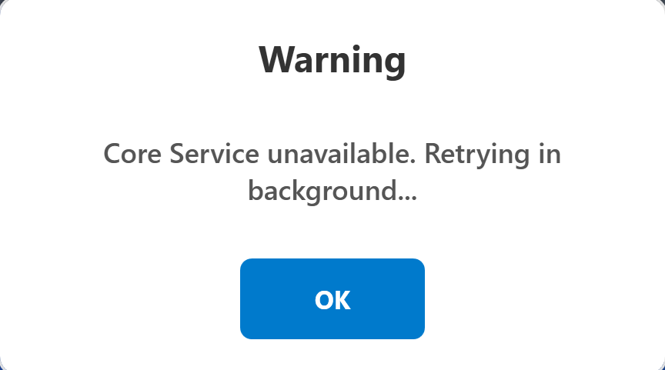

### Important Notes for Operator

* This warning does **not** indicate a system crash.
* The AOI application remains operational while service reconnection is in progress.
* Operators should **not restart or shut down the application** unless instructed by authorized maintenance or engineering personnel.

## **2 Login Screen**

### **Screen Name**

**User Login Screen**

### Purpose

The Login screen allows authorized users to access the AOI system based on their assigned roles and permissions.

### Screen Overview

The Login screen consists of:

* Username input field
* Password input field
* Login button

This screen is displayed after system startup or after acknowledging a service warning message.

### Login Procedure

1. Enter the assigned **Username**.
2. Enter the corresponding **Password**.
3. Click the **LOGIN** button to proceed.

### **System Behavior**

* The system validates the entered credentials and identifies the associated user role.
* Based on the logged-in role, system access and available features are automatically adjusted.

**Operator Login**

* Provides access only to operation-related screens and functions.

**Administrator Login**

* Provides full system access, including configuration, diagnostics, and maintenance functions.

If backend services are still unavailable, certain system functions may remain restricted until services are restored.

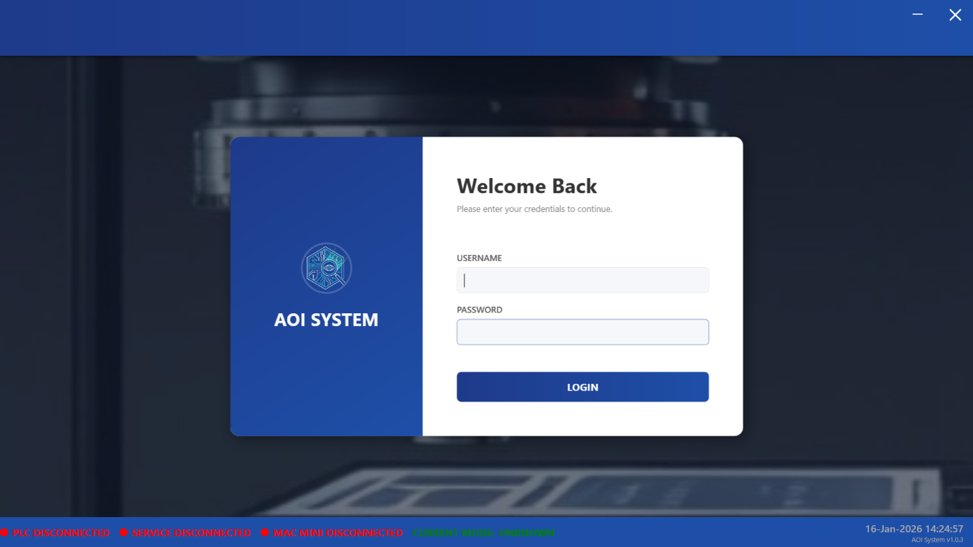

### Operator Guidelines

* Ensure that all system indicators display **Connected** status after login.
* If service warnings continue to appear after login:
  + Inform maintenance or engineering personnel.
  + Do not start inspection or production operations until the issue is resolved.

**3 System Status Indicators**

### Purpose

Status indicators provide real-time information about the connectivity and operational readiness of the AOI system.

### Displayed Status Indicators

**PLC Status** – Connected / Disconnected

**Core Service Status** – Connected / Disconnected

**Vision System (Mac Mini)** – Connected / Disconnected

**Current Mode** – Displays the current operating mode of the system

### **Operator Responsibility**

Verify that all required system components show **Connected** status before starting production.

Do not operate the machine if any critical service is shown as disconnected.

Immediately report abnormal or unknown system status conditions.

## **4. Safety and Operational Notes**

Do not ignore repeated warning or status messages.

Do not attempt unauthorized configuration or parameter changes.

Always follow company-defined safety, escalation, and operating procedures.

Report persistent system warnings or connection issues immediately to authorized personnel.

**5 Control Screen**

### **5.1 Screen Name**

**Control Screen**

### **5.2 Purpose**

The Control screen allows the user to operate and control the AOI machine based on the selected operating mode.  
This screen provides access to machine operation functions according to the logged-in user’s role and system status.

### **5.3 Screen Overview**

The Control screen is displayed immediately after a successful login.  
It provides primary machine control options and real-time operational feedback.

The screen consists of the following main sections:

* Machine control buttons for operation mode selection
* Operation Activity Log for system events and actions

The availability of controls depends on:

* Logged-in user role (Operator or Administrator)
* Machine state and service connectivity

### **5.4 Available Control Options**

#### **5.4.1 Auto Run**

* Starts the machine in automatic inspection mode.
* Used for normal production operation.
* The machine performs inspection cycles automatically using configured parameters.
* This mode is typically used during regular production shifts.

#### **5.4.2 Dry Run**

* Starts the machine without performing actual inspection or processing.
* Used for system verification, functional checks, and trial runs.
* No inspection results or production data are recorded in this mode.

#### **5.4.3 Manual**

* Allows manual control of machine movements and operations.
* Used for setup, adjustment, and maintenance-related activities.
* Access to manual operations may be restricted for operator-level users.

#### **5.4.4 Cycle Stop**

* Safely stops the currently running machine cycle.
* Ensures controlled and safe stopping of machine motion.
* Used during abnormal conditions or when production needs to be halted.

#### **5.4.5 Machine Home**

* Moves the machine to its predefined home position.
* Ensures the machine is placed in a safe and known reference state.
* Recommended after startup, cycle stop, or before starting Auto Run.

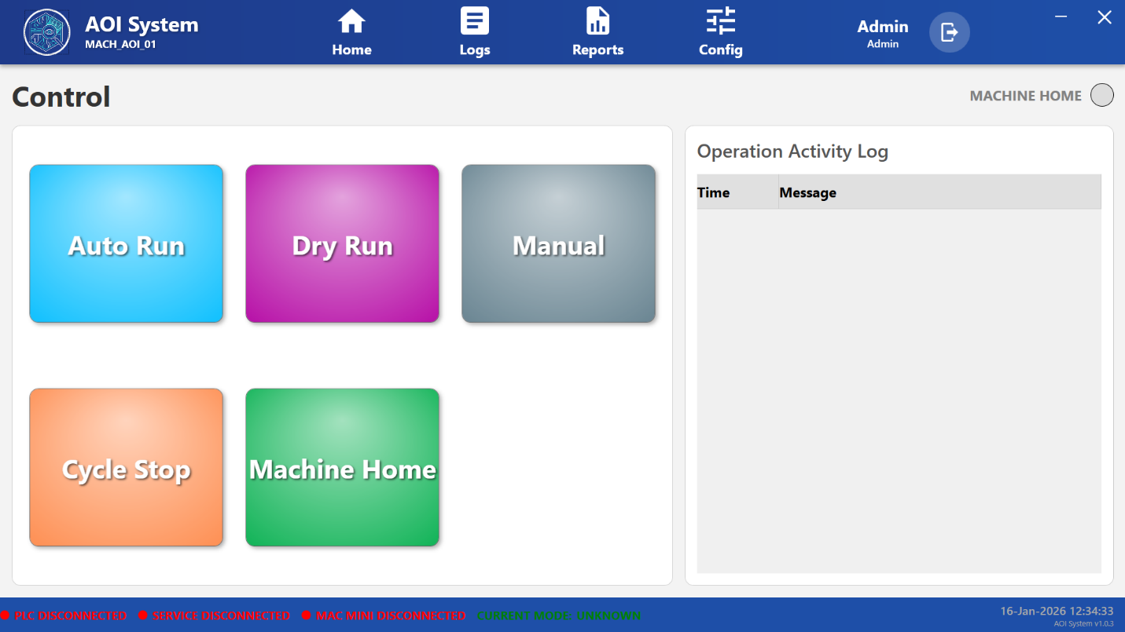

**5.5 Operation Activity Log**

#### 5.5.1 Purpose

Displays real-time messages related to machine operations and system events.

#### **5.5.2 Displayed Information**

• **Time** – Timestamp indicating when the event occurred.  
• **Message** – Description of the system action or operation.

The Operation Activity Log helps operators and administrators monitor machine behavior, track recent actions, and identify abnormal or unexpected conditions.

### **5.6 System Behavior**

• Control button and menu availability is dynamically updated based on:

* Current machine operating mode
* PLC, Core Service, and Vision System connectivity
* Logged-in user role (Operator or Administrator)

• If any critical service is disconnected, certain controls and operations may remain disabled to ensure safe machine operation.

### **5.7 Operator Guidelines**

• Ensure all system status indicators display **Connected** before starting Auto Run.  
• Perform **Machine Home** after system startup and before initiating production.  
• Use **Dry Run** to verify correct machine behavior after setup or configuration changes.  
• Use **Cycle Stop** only when required and wait until the machine comes to a complete stop.

### **5.8 Safety and Operational Notes**

• Do not operate the machine if any critical service is disconnected.  
• Do not attempt manual, configuration, or diagnostic actions without proper authorization.  
• Always follow company-defined safety procedures and escalation guidelines.  
• Report persistent warnings or abnormal system behavior immediately to maintenance or engineering personnel.

### **5.9 Operator Note**

Access to Control screen functions and menu options is strictly role-based.  
Administrator users have additional access to configuration, diagnostics, and system-level controls that are not available to standard operators.

**6 Auto Run Operation**

### **6.1 Screen Name**

**Auto Run Mode**

### **6.2 Purpose**

The Auto Run mode allows the AOI system to operate in fully automatic inspection mode for normal production.  
In this mode, the machine performs inspection cycles automatically based on predefined and configured parameters.

### **6.3 Screen Overview**

The Auto Run operation is initiated when the operator clicks on the **Auto Run** button from the Control screen.

Upon selection:

* The system switches to Automatic Operation Mode.
* The machine prepares itself for continuous inspection cycles.
* Operator actions are recorded in the Operation Activity Log.

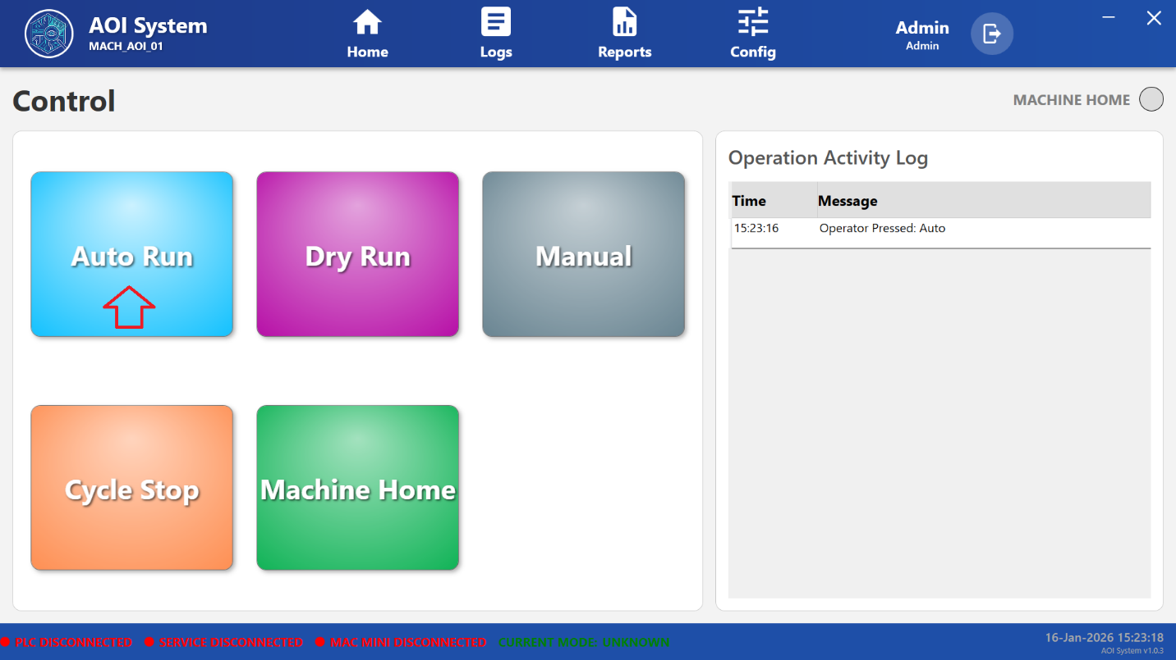

### **6.4 System Behavior**

When Auto Run is selected:

• The system changes the current operating mode to **Auto**.  
• The machine starts executing automatic inspection cycles.  
• The selected action is logged in the Operation Activity Log with date and time.  
• The operator interface reflects the active Auto Run state.

Example log entry:  
**Message:** Operator Pressed: Auto

### **6.5 Operation Activity Log Update**

The following information is recorded in the Operation Activity Log during Auto Run initiation:

• **Time** – Exact time when Auto Run was selected  
• **Message** – Indicates that the operator has initiated Auto Run mode

This information provides traceability of operator actions during production.

### **6.6 System Conditions**

Auto Run mode can be initiated only when the following conditions are met:

• Core Service is connected  
• PLC communication is available  
• Vision system (Mac Mini) is connected  
• No critical alarms are active  
• Machine is in a safe and ready state

If any required condition is not satisfied, Auto Run may not start.

### **6.7 Operator Guidelines**

• Ensure **Machine Home** has been completed before starting Auto Run.  
• Verify that all system status indicators display **Connected** status.  
• Monitor the Operation Activity Log during operation.  
• Do not leave the machine unattended during Auto Run.

### **6.8 Safety and Operational Notes**

• Do not attempt manual intervention while Auto Run is active.  
• Do not start Auto Run if any service or PLC is disconnected.  
• Follow all company-defined safety and operating procedures.  
• Use **Cycle Stop** in case of abnormal machine behavior.

**7 Dry Run Operation**

### **7.1 Screen Name**

**Dry Run Mode**

### **7.2 Purpose**

Dry Run mode is used to verify machine movement, sequence flow, and system readiness without performing actual inspection or production.  
This mode helps ensure safe operation before starting Auto Run.

### **7.3 Screen Overview**

Dry Run mode is activated when the operator clicks on the **Dry Run** button from the Control screen.

Upon selection:

* The AOI system switches to Dry Run mode.
* The selected action is displayed in the Operation Activity Log.
* The machine executes predefined movements without inspection processing.

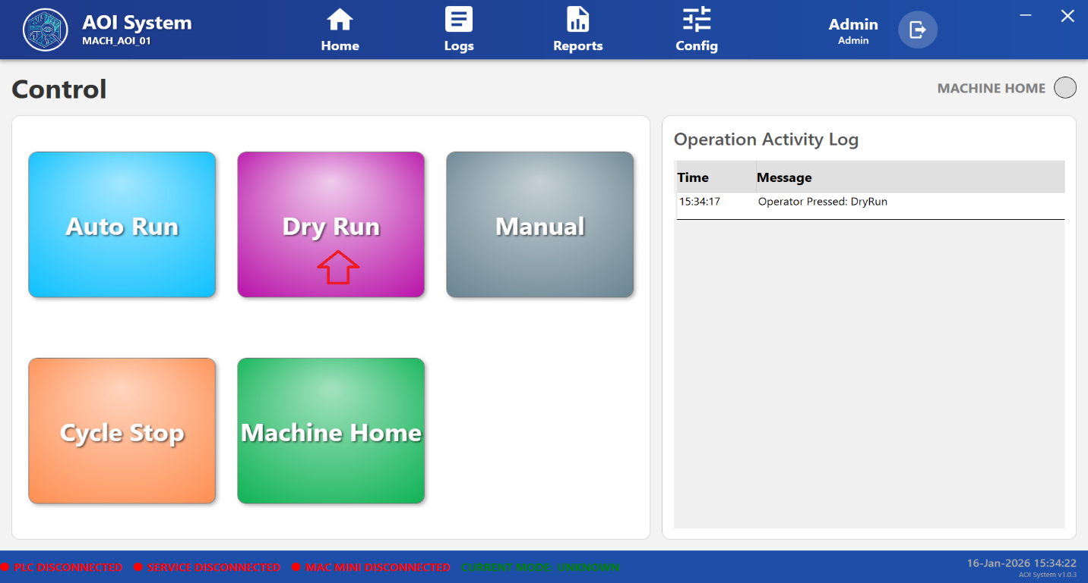

### **7.4 System Behavior After Selecting Dry Run**

When Dry Run is selected:

• The system enters **test operation mode**.  
• Machine movements are executed according to configured paths and sequences.  
• Inspection algorithms are not executed.  
• No inspection results or production data are generated or stored.  
• The current operating mode is updated to **Dry Run**.

### **7.5 Operation Activity Log Update**

After selecting Dry Run, the system records the action in the **Operation Activity Log**.

**Example Log Entry:**  
**Message:** Operator Pressed: DryRun

The log entry contains:  
• Time when Dry Run mode was selected  
• Message describing the operator action

This ensures traceability of operator-initiated mode changes.

### **7.6 Typical Use Cases**

Dry Run mode is typically used for:

• Machine setup and verification  
• Motion path and sequence testing  
• Maintenance and troubleshooting activities  
• Operator training and system validation

### **7.7 Operator Guidelines**

• Ensure the work area is clear before starting Dry Run.  
• Do not load any production material during Dry Run.  
• Observe machine movements closely during operation.  
• Use Dry Run to confirm system readiness before switching to Auto Run.

### **7.8 Safety and Operational Notes**

• Dry Run does not perform inspection; results should not be used for quality decisions.  
• Do not bypass safety mechanisms during Dry Run.  
• Immediately stop the machine using **Cycle Stop** if abnormal behavior is observed.

### **7.9 Operator Note**

Dry Run mode is intended for testing and verification purposes only.  
Production inspection must be performed only in Auto Run mode.

## **8 Manual Operation Mode**

### **8.1 Screen Name**

**Manual Operation Pane**

### **8.2 Purpose**

Manual Operation Mode allows authorized users to manually control individual machine components and axis movements.  
This mode is primarily used for setup, adjustment, testing, and maintenance activities.

### **8.3 Screen Overview**

The Manual Operation Panel is displayed when the user clicks on the **Manual** button from the Control screen.

This screen provides direct control over machine actuators, conveyors, and axis movements.  
A **Back** button is provided to return to the Control screen.

**Note:** Access to manual operations may be restricted based on the logged-in user role.

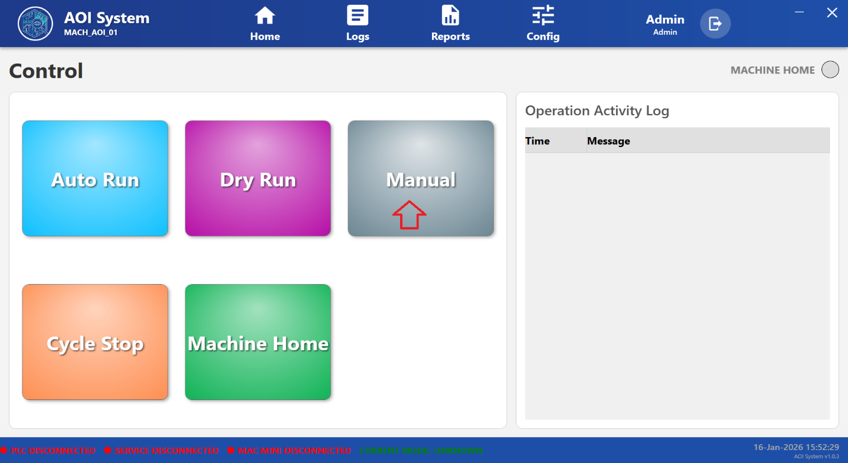

**8.4 Available Manual Controls**

#### 8.4.1 Tray Lift Control

* **UP** – Moves the tray lift upward.
* **DOWN** – Moves the tray lift downward.

Used to adjust tray height during setup or maintenance.

#### 8.4.2 Positioning Cylinder Control

* **UP** – Extends the positioning cylinder.
* **DOWN** – Retracts the positioning cylinder.

Used for part positioning and mechanical alignment.

#### **8.4.3 Transport Conveyor Control**

* **REV** – Moves the conveyor in reverse direction.
* **FWD** – Moves the conveyor in forward direction.
* **STOP** – Stops conveyor movement.
* **LOW** – Sets conveyor speed to low.
* **HIGH** – Sets conveyor speed to high.

Used to manually control material movement during testing or troubleshooting.

#### **8.4.4 Move to Position**

* **X-Y ORIGIN** – Moves the machine to the defined X-Y origin reference position.
* **Position 0 – 12** – Moves the machine to predefined stored positions.

Used for precise positioning during setup, calibration, or maintenance.

#### **8.4.5 Manual X-Axis Jog**

* **X JOG −** – Moves the X-axis in the negative direction.
* **X JOG +** – Moves the X-axis in the positive direction.

Used for fine positioning and alignment along the X-axis.

#### **8.4.6 Manual Y-Axis Jog**

* **Y JOG −** – Moves the Y-axis in the negative direction.
* **Y JOG +** – Moves the Y-axis in the positive direction.

Used for fine positioning and alignment along the Y-axis.

### **8.5 System Behavior**

* Each manual action is executed immediately upon user input.
* Movements are limited by predefined safety limits and interlocks.
* The system may restrict certain actions if:
  + PLC or services are disconnected
  + Machine is not in a safe state
  + User role does not permit manual access

### **8.6 Operator Guidelines**

* Ensure the work area is clear before performing any manual operation.
* Perform manual movements slowly and carefully.
* Use jog controls for fine alignment only.
* Always return the machine to a safe position after manual operation.

### **8.7 Safety and Operational Notes**

* Manual mode should be used only by trained and authorized personnel.
* Do not bypass safety interlocks or protective mechanisms.
* Keep hands and tools away from moving parts during operation.
* Use **Cycle Stop** immediately if abnormal behavior is observed.

### **8.8 Operator Note**

Manual Operation Mode is intended for setup, adjustment, and maintenance activities only.  
Normal production and inspection must be performed in **Auto Run mode**.

**9 Cycle Stop Operation**

### **9.1 Screen Name**

**Cycle Stop**

### **9.2 Purpose**

The Cycle Stop function is used to safely stop the currently running machine operation or inspection cycle.  
It allows the operator to halt machine movement in a controlled manner without abruptly shutting down the system.

### **9.3 Screen Overview**

The Cycle Stop operation is initiated when the operator clicks on the **Cycle Stop** button from the Control screen.

Upon selection:

* The system interrupts the active cycle.
* Machine motion is brought to a safe stop.
* The operator action is recorded in the Operation Activity Log.

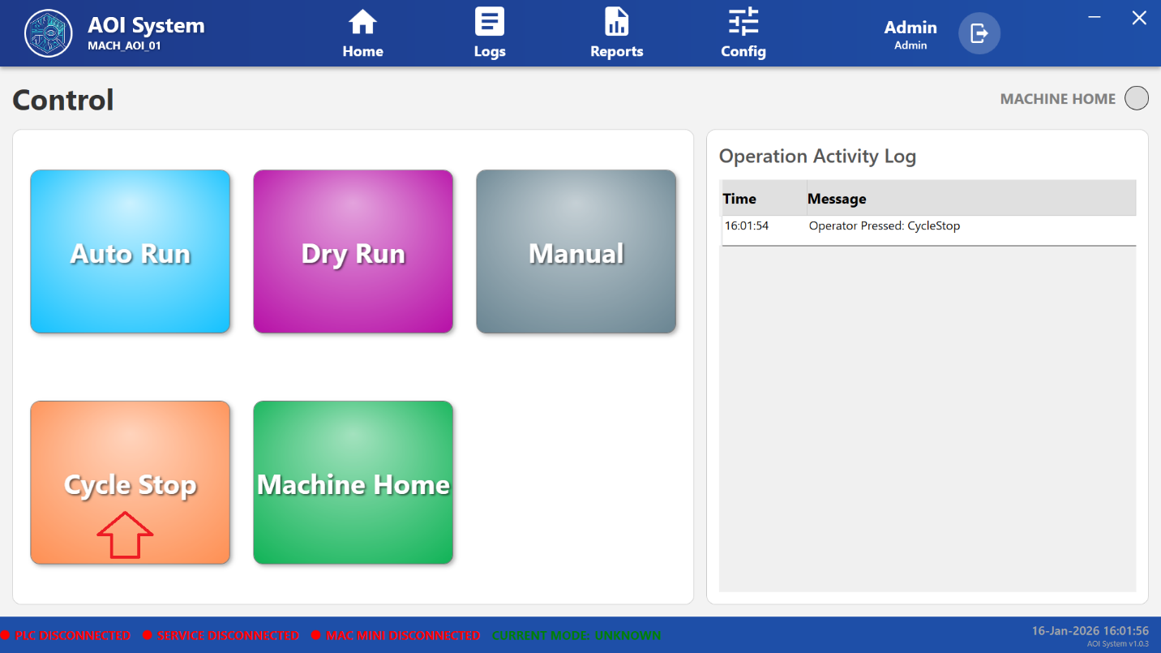

### **9.4 System Behavior After Selecting Cycle Stop**

When Cycle Stop is pressed:

• The current operation or inspection cycle is stopped safely.  
• Ongoing machine movements are halted in a controlled sequence.  
• The system remains powered and active.  
• The current operating mode is updated accordingly.  
• The action is logged in the Operation Activity Log.

### **9.5 Operation Activity Log Update**

After selecting Cycle Stop, the system records the event in the **Operation Activity Log**.

**Example Log Entry:**  
**Message:** Operator Pressed: CycleStop

The log entry contains:  
• **Time** – Exact time when Cycle Stop was pressed  
• **Message** – Description of the operator action

This ensures traceability of operator-initiated stop actions.

### **9.6 Typical Use Cases**

Cycle Stop is typically used in the following situations:

• Abnormal machine behavior  
• Inspection or production interruption  
• Operator intervention requirement  
• Preparation before switching operation modes

### **9.7 Operator Guidelines**

• Use Cycle Stop to halt operations safely when required.  
• Do not power off the system immediately after Cycle Stop.  
• Wait until all machine movements have completely stopped.  
• Perform **Machine Home** before restarting Auto Run or Dry Run, if required.

### **9.8 Safety and Operational Notes**

• Cycle Stop does not shut down the system; it only stops the current cycle.  
• Do not use emergency power shutdown unless instructed by safety procedures.  
• Investigate the reason for stopping before resuming operation.  
• Inform maintenance personnel if Cycle Stop is triggered repeatedly.

### **9.9 Operator Note**

Cycle Stop is a controlled stopping function intended for normal operational use.  
Emergency situations must be handled according to plant safety and emergency stop procedures.

10 Machine Home Operation

### **10.1 Screen Name**

**Machine Home**

### **10.2 Purpose**

The Machine Home function is used to move the AOI machine to its predefined home or reference position.  
This ensures that the machine is aligned to a known and safe starting point before beginning any operation.

### **10.3 Screen Overview**

The Machine Home operation is initiated when the operator clicks on the **Machine Home** button from the Control screen.

Upon selection:

* The machine starts moving towards its predefined reference positions.
* Axis movements are executed sequentially based on system configuration.
* The operator action is recorded in the Operation Activity Log.

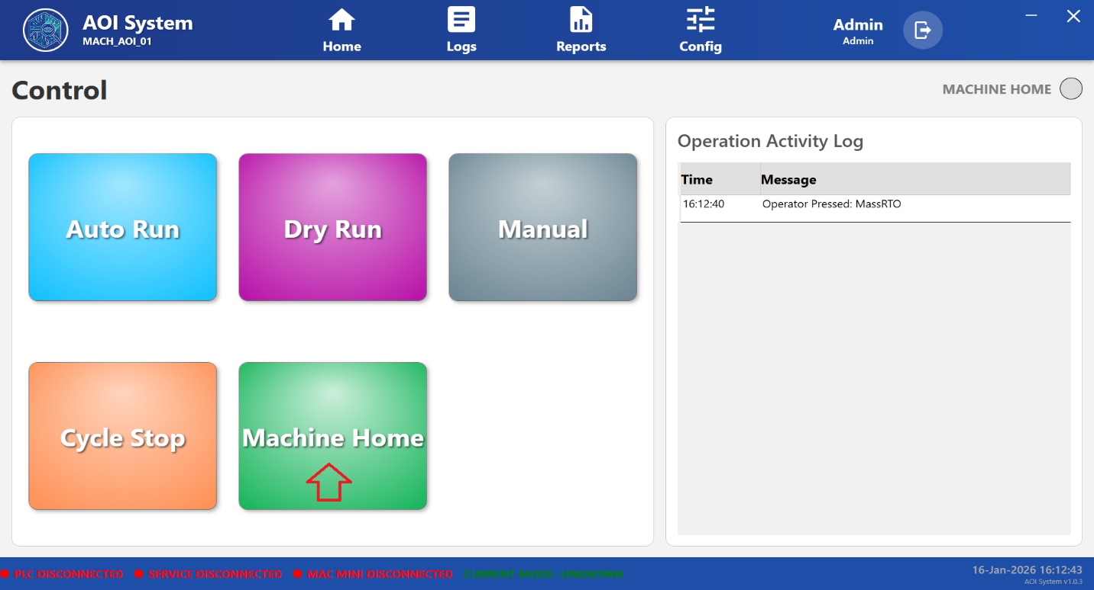

### **10.4 System Behavior After Selecting Machine Home**

When Machine Home is selected:

• The system initiates the homing sequence for machine axes.  
• All movements are performed under controlled speed and safety limits.  
• The machine reaches its predefined home or origin position.  
• The current operating mode is updated accordingly.  
• The action is logged in the Operation Activity Log.

### **10.5 Operation Activity Log Update**

After selecting Machine Home, the system records the event in the **Operation Activity Log**.

**Example Log Entry:**  
**Message:** Operator Pressed: MassRTO

The log entry contains:  
• **Time** – Exact time when Machine Home was initiated  
• **Message** – Description of the operator action

This log ensures traceability of homing operations.

### **10.6 Typical Use Cases**

Machine Home is typically performed in the following situations:

• After system startup  
• After Cycle Stop operation  
• Before starting Auto Run or Dry Run  
• After manual intervention or maintenance activities

### **10.7 Operator Guidelines**

• Ensure no obstructions are present in the machine movement area.  
• Do not interrupt the homing process once initiated.  
• Wait until the homing sequence is fully completed.  
• Verify that the machine has reached the home position before starting any operation.

### **10.8 Safety and Operational Notes**

• Do not attempt manual movement during Machine Home operation.  
• Do not power off the system while homing is in progress.  
• If abnormal movement is observed, use **Cycle Stop** immediately.  
• Inform maintenance personnel if Machine Home fails repeatedly.

### **10.9 Operator Note**

Machine Home operation establishes the reference position for all subsequent machine movements.  
Proper homing is mandatory before starting production or inspection operations.

## **11 Home Screen and Navigation Menu**

### **11.1 Screen Name**

**Home Screen**

### **11.2 Purpose**

The Home screen provides access to the main navigation menu of the AOI system.  
It allows the operator or administrator to navigate between different system screens such as Control, PLC IO, Alarms, and Startup conditions.

### **11.3 Screen Overview**

The Home screen is displayed when the user clicks on the **Home** option from the top navigation bar.

Upon selection:

* A left-side navigation menu is displayed.
* The currently active screen remains visible in the background.
* The menu provides quick access to key system modules.

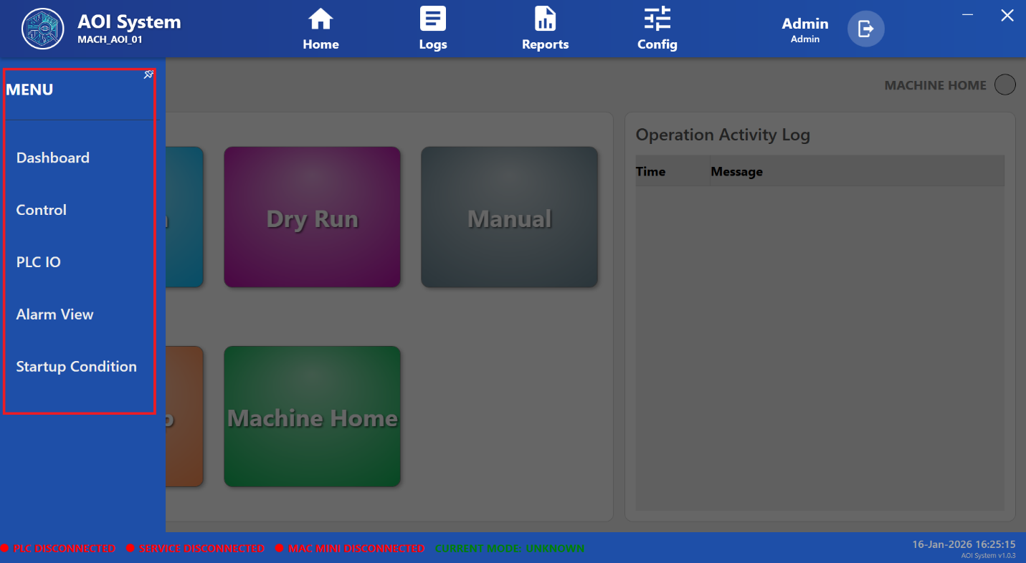

### **11.4 Left Navigation Menu**

The left navigation menu contains the following options:

#### **11.4.1 Dashboard**

* Displays overall system and machine status.
* Provides a high-level overview of machine readiness and operational state.
* Typically used as the primary monitoring screen.

#### **11.4.2 Control**

* Navigates to the **Control Screen**.
* Allows access to Auto Run, Dry Run, Manual, Cycle Stop, and Machine Home operations.
* Used for daily machine operation.

#### **11.4.3 PLC IO**

* Opens the PLC IO monitoring screen.
* Used to view real-time PLC input and output status.
* Access may be restricted based on the logged-in user role.

#### **11.4.4 Alarm View**

* Displays active, historical, or acknowledged system alarms.
* Helps operators identify abnormal conditions.
* Used for fault monitoring and troubleshooting.

#### **11.4.5 Startup Condition**

* Displays startup readiness and prerequisite conditions.
* Helps verify that all required conditions are satisfied before starting machine operation.
* Used prior to Auto Run or Dry Run initiation.

### **11.5 System Behavior**

* The navigation menu remains visible until manually closed or changed.
* The selected menu item is highlighted for easy identification.
* Some menu options may be disabled if:
  + User role does not permit access
  + System services or PLC are disconnected

### **11.6 Operator Guidelines**

* Use the Home menu to navigate between system screens instead of restarting the application.
* Always verify system status before moving to operation-related screens.
* Report any unavailable or disabled menu options to maintenance personnel if unexpected.

### **11.7 Safety and Operational Notes**

* Do not change screens during critical machine movement unless required.
* Always ensure machine is in a safe state before accessing diagnostic or PLC-related screens.
* Follow company-defined access control and operating procedures.

**12 Dashboard Screen**

### **12.1 Screen Name**

**Dashboard**

### **12.2 Purpose**

The Dashboard screen provides a centralized overview of the AOI system’s current operational status.  
It allows operators and administrators to quickly assess machine readiness, connectivity status, and overall system health.

### **12.3 Screen Overview**

The Dashboard screen is displayed when the user selects **Dashboard** from the Home navigation menu.

This screen presents key system information and status indicators in a consolidated view, enabling fast decision-making before starting or monitoring operations.

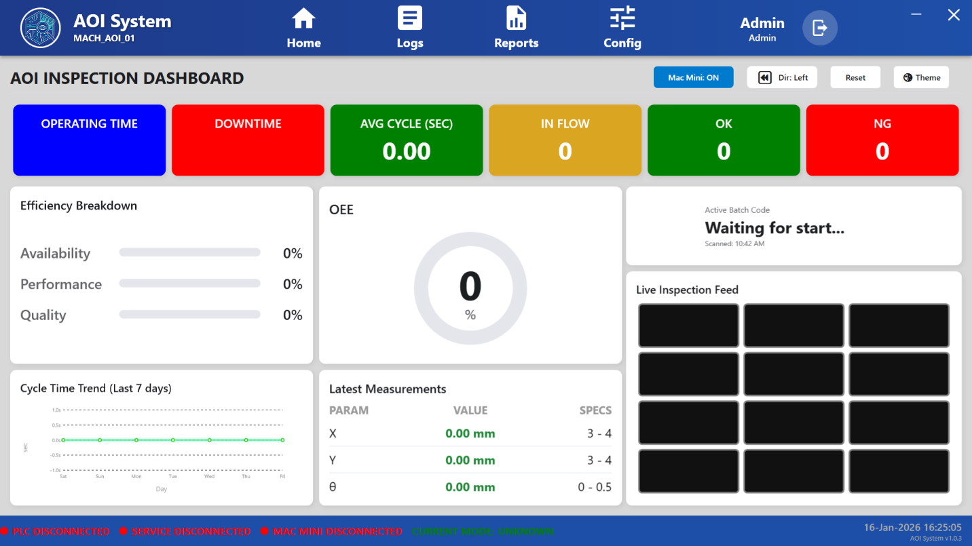

### **12.4 Displayed Information**

The Dashboard screen displays the following information:

#### **12.4.1 System Connectivity Status**

Shows the real-time connection status of critical system components, including:

* **PLC Status** – Indicates whether PLC communication is connected or disconnected
* **Core Service Status** – Displays backend service connectivity
* **Vision System (Mac Mini) Status** – Indicates vision system availability

These indicators help verify system readiness.

#### **12.4.2 Current Operating Mode**

* Displays the current machine operating mode (Auto Run, Dry Run, Manual, or Unknown).
* Helps the operator identify the active system state at a glance.

#### **12.4.3 Machine Status Information**

* Provides information related to machine availability and readiness.
* Reflects whether the machine is safe to operate or requires attention.

### **12.5 System Behavior**

* Dashboard information is updated automatically in real time.
* Status indicators change dynamically based on system connectivity and machine state.
* If any critical component is disconnected, the Dashboard reflects the condition immediately.

### **12.6 Operator Guidelines**

* Always review the Dashboard before starting Auto Run or Dry Run.
* Ensure all critical system components show **Connected** status.
* Do not proceed with production if the Dashboard indicates abnormal or disconnected states.

### **12.7 Safety and Operational Notes**

* Dashboard is a monitoring screen only and does not initiate machine movement.
* Use Control screen for operational actions.
* Report persistent disconnected or abnormal status indications to maintenance personnel.

### **12.8 Operator Note**

Dashboard access is available to all authorized users.  
Displayed information may vary slightly based on user role and system configuration.

**13 Operating Time Screen**

### **13.1 Screen Name**

**Operating Time**

### **13.2 Purpose**

The Operating Time screen displays the total duration for which the AOI system has been operational.  
It helps operators and supervisors monitor machine usage over different time periods.

### **13.3 Screen Overview**

The Operating Time screen is displayed when the user clicks on **Operating Time** from the Dashboard or relevant menu option.

This screen presents operating duration data in a tabular format, categorized by time range.

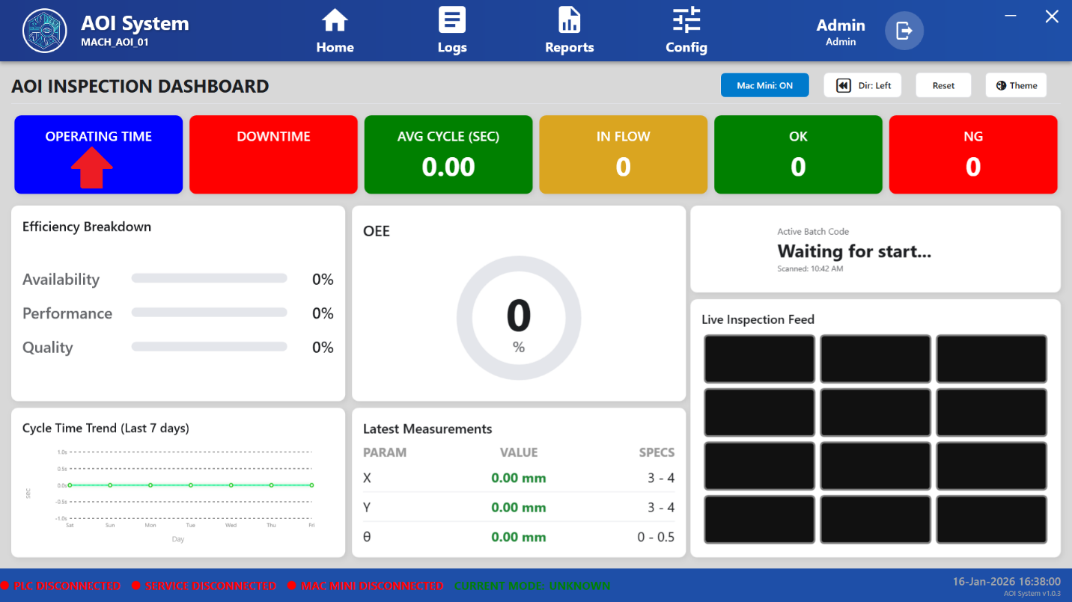

A **Close** button is provided to exit the screen and return to the previous view.

### **13.4 Displayed Information**

The Operating Time screen displays the following metrics:

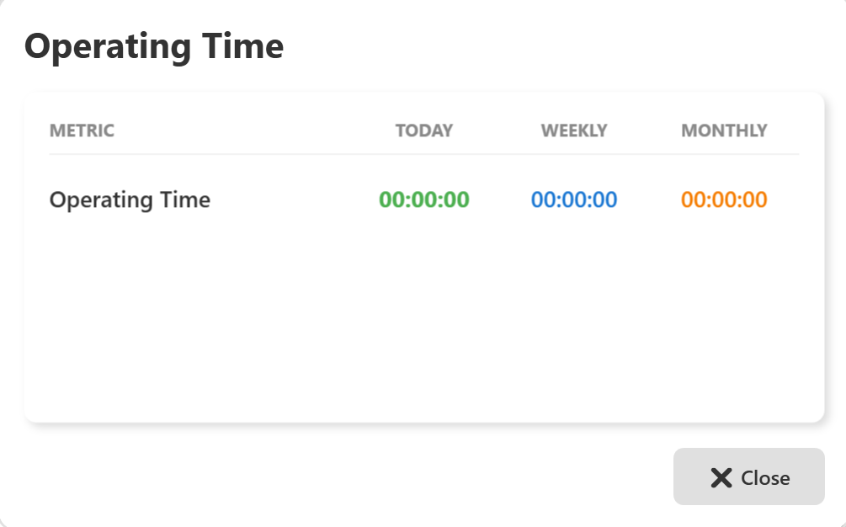

#### **13.4.1 Metric**

* **Operating Time** – Represents the total active running time of the machine.

#### **13.4.2 Today**

* Displays the total operating time accumulated for the current day.
* The value resets at the start of a new day.

#### **13.4.3 Weekly**

* Displays the total operating time accumulated during the current week.
* Used to track short-term machine utilization.

#### **13.4.4 Monthly**

* Displays the total operating time accumulated during the current month.
* Used for long-term performance and utilization analysis.

### **13.5 System Behavior**

* Operating time values are updated automatically by the system.
* Time is recorded only when the machine is in an active operational state.
* If the machine is idle or stopped, operating time does not increase.

### **13.6 Operator Guidelines**

* Use Operating Time information to verify machine utilization.
* Review daily, weekly, and monthly values regularly.
* Inform supervisors or maintenance personnel if operating time values appear abnormal or incorrect.

### **13.7 Safety and Operational Notes**

* Operating Time is a monitoring feature only and does not control machine operation.
* Values shown are for reference and analysis purposes.
* Do not rely on Operating Time alone for safety-related decisions.

### **13.8 Operator Note**

Operating Time data may be used for production analysis, maintenance planning, and performance reporting.  
Access to this screen is generally available to all authorized users.

## **14 Downtime Statistics Screen**

### **14.1 Screen Name**

**Downtime Statistics**

### **14.2 Purpose**

The Downtime Statistics screen displays the total duration for which the AOI system was stopped or not in operation.  
This information helps operators, supervisors, and maintenance teams analyze machine stoppages and improve productivity.

### **14.3 Screen Overview**

The Downtime Statistics screen is displayed when the user clicks on **Downtime** from the Dashboard or relevant menu option.

This screen presents downtime data in a summarized table format based on different time periods.  
A **Close** button is provided to exit the screen and return to the previous view.

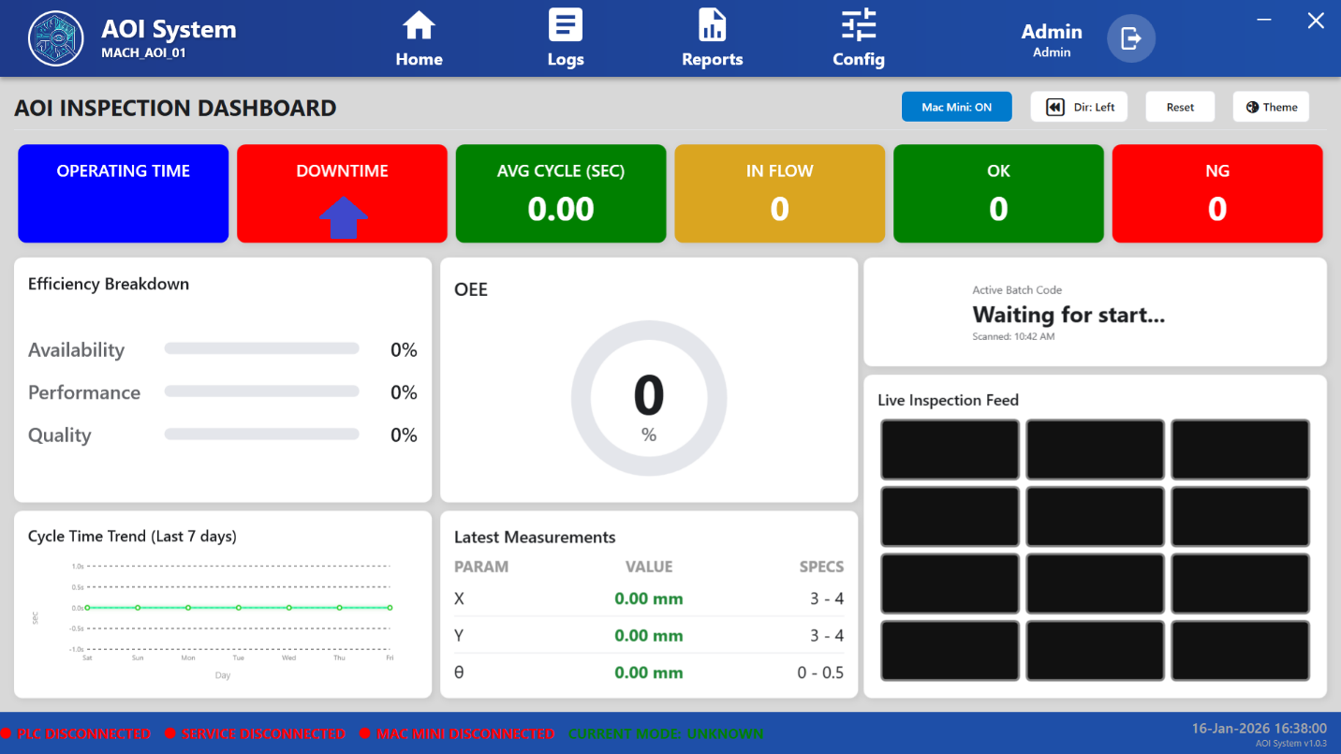

### **14.4 Displayed Information**

The Downtime Statistics screen displays the following details:

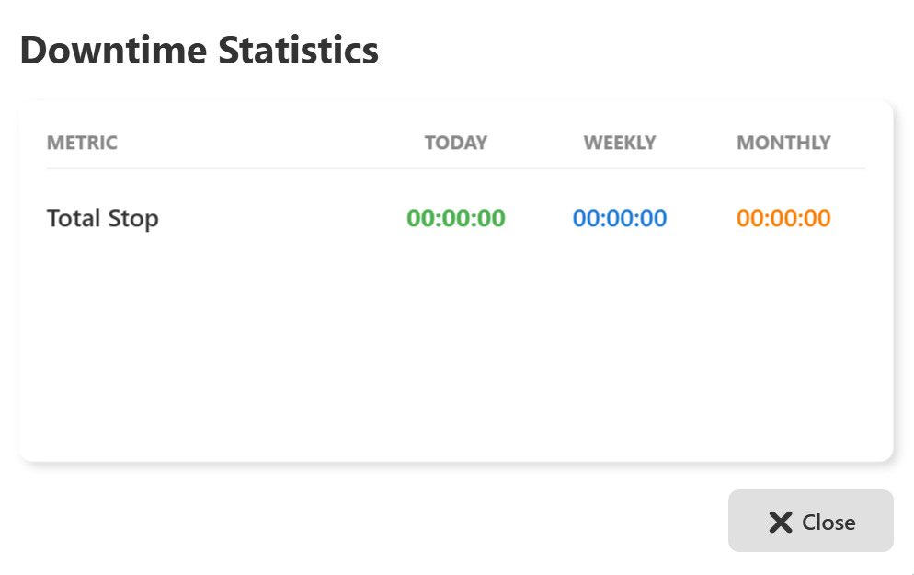

#### **14.4.1 Metric**

* **Total Stop** – Represents the total time duration during which the machine was stopped or not operating.

#### **14.4.2 Today**

* Displays the total downtime accumulated for the current day.
* The value resets automatically at the start of a new day.

#### **14.4.3 Weekly**

* Displays the total downtime accumulated during the current week.
* Used to analyze short-term stoppage trends.

#### **14.4.4 Monthly**

* Displays the total downtime accumulated during the current month.
* Used for long-term downtime analysis and performance reporting.

### **14.5 System Behavior**

* Downtime values are calculated automatically by the system.
* Time is recorded when the machine is in a stopped or non-operational state.
* Downtime accumulation stops when the machine resumes operation.

### **14.6 Operator Guidelines**

* Regularly review downtime values to understand machine stoppage patterns.
* Report excessive or unexpected downtime to maintenance or engineering teams.
* Use downtime information for shift-level and daily performance review.

### **14.7 Safety and Operational Notes**

* Downtime Statistics is a monitoring and analysis feature only.
* This screen does not allow control or modification of machine operation.
* Downtime data should be used along with Operating Time and Alarm information for accurate analysis.

### **14.8 Operator Note**

Downtime Statistics data supports production analysis, maintenance planning, and continuous improvement activities.  
Access to this screen is generally available to all authorized users.

## **15 Cycle Time Trends Screen**

### **15.1 Screen Name**

**Cycle Time Trends**

### **15.2 Purpose**

The Cycle Time Trends screen displays the average cycle time of the AOI system over different time periods.  
It helps operators and supervisors monitor production speed, consistency, and overall machine performance.

### **15.3 Screen Overview**

The Cycle Time Trends screen is displayed when the user clicks on **Avg Cycle** or **Cycle Time** from the Dashboard.

This screen presents average cycle time values in a summarized table format for quick analysis.  
A **Close** button is provided to exit the screen and return to the previous view.

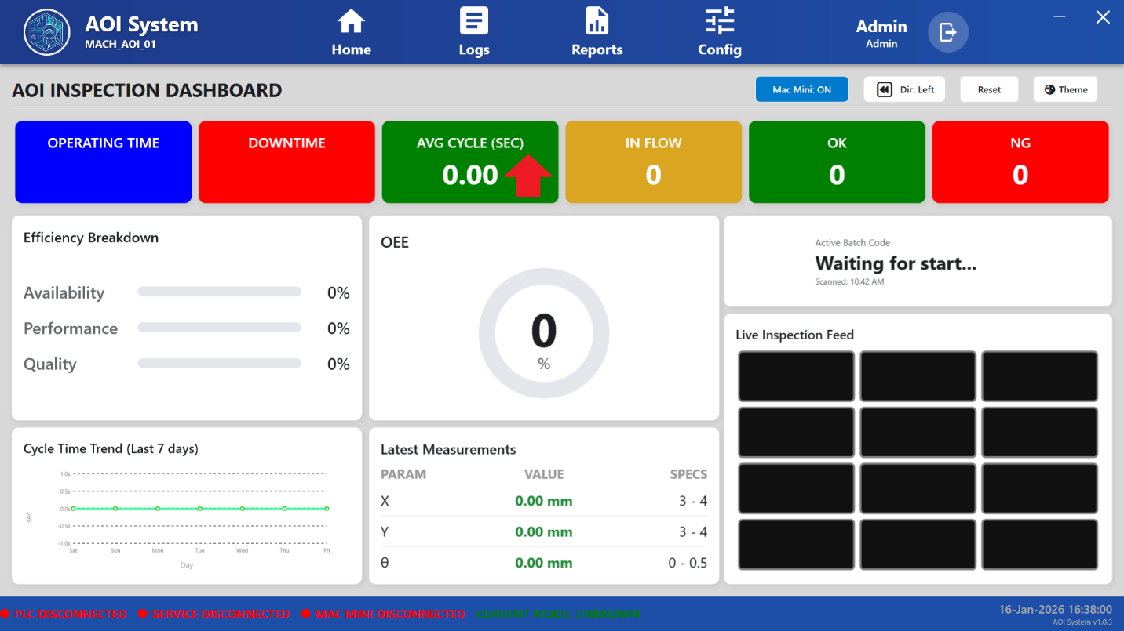

### **15.4 Displayed Information**

The Cycle Time Trends screen displays the following information:

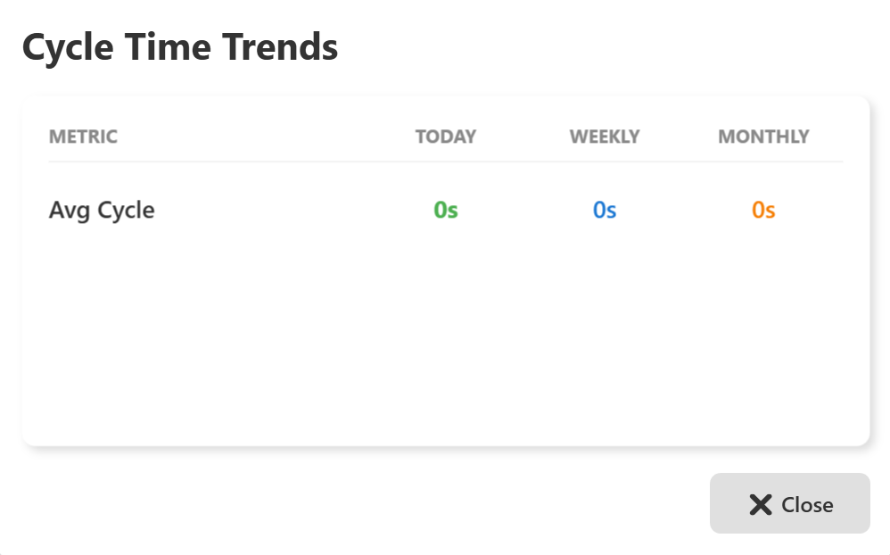

#### **15.4.1 Metric**

* **Avg Cycle** – Represents the average time taken by the machine to complete one inspection or production cycle.

#### **15.4.2 Today**

* Displays the average cycle time calculated for the current day.
* Reflects short-term production performance.

#### **15.4.3 Weekly**

* Displays the average cycle time calculated for the current week.
* Used to identify weekly performance trends and variations.

#### **15.4.4 Monthly**

* Displays the average cycle time calculated for the current month.
* Used for long-term performance monitoring and reporting.

### **15.5 System Behavior**

* Cycle time values are calculated automatically by the system.
* Only completed cycles are considered for average calculation.
* If no production cycles are completed, the value may be displayed as **0s**.

### **15.6 Operator Guidelines**

* Monitor average cycle time to ensure production is running within expected limits.
* Compare daily, weekly, and monthly values to identify performance changes.
* Inform supervisors or maintenance personnel if abnormal increases in cycle time are observed.

### **15.7 Safety and Operational Notes**

* Cycle Time Trends is a monitoring and analysis feature only.
* This screen does not allow modification of machine operation.
* Cycle time data should be reviewed along with Operating Time and Downtime statistics for accurate analysis.

### **15.8 Operator Note**

Cycle Time Trends data is useful for productivity analysis, process optimization, and continuous improvement activities.  
Access to this screen is generally available to all authorized users.

**16 Input Statistics Screen**

### **16.1 Screen Name**

**Input Statistics**

### **16.2 Purpose**

The Input Statistics screen displays the total number of inputs processed by the AOI system over different time periods.  
This screen helps operators and supervisors monitor production volume and input flow trends.

### **16.3 Screen Overview**

The Input Statistics screen is displayed when the user clicks on **In Flow** or **Input Flow** from the Dashboard.

This screen presents input count data in a summarized table format.  
A **Close** button is provided to exit the screen and return to the previous view.

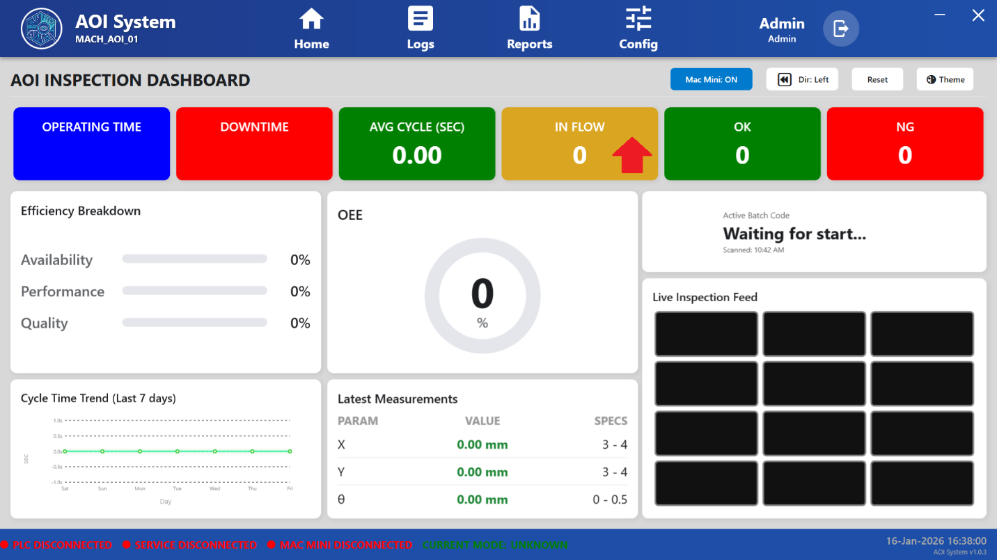

### **16.4 Displayed Information**

The Input Statistics screen displays the following details:

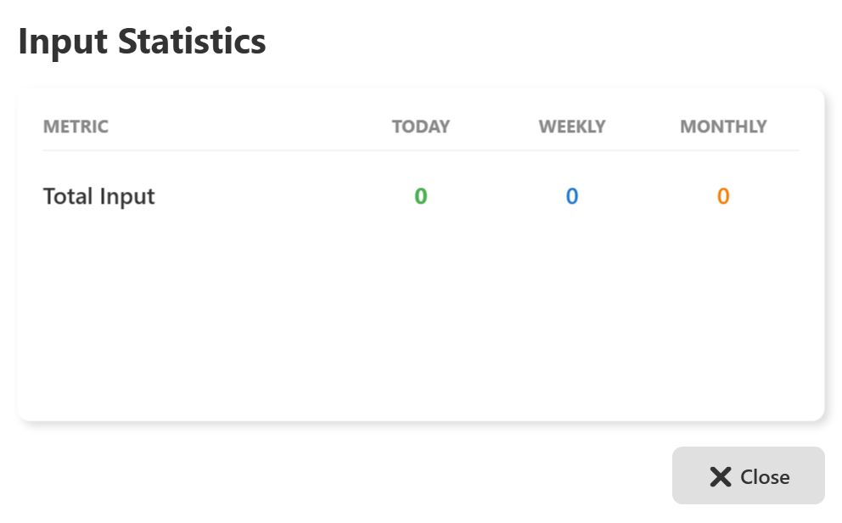

#### **16.4.1 Metric**

* **Total Input** – Represents the total number of parts or units received by the AOI system.

#### **16.4.2 Today**

* Displays the total input count recorded for the current day.
* The value resets automatically at the start of a new day.

#### **16.4.3 Weekly**

* Displays the total input count accumulated during the current week.
* Used to monitor short-term production volume.

#### **16.4.4 Monthly**

* Displays the total input count accumulated during the current month.
* Used for long-term production analysis and reporting.

### **16.5 System Behavior**

* Input counts are updated automatically by the system.
* The count increases whenever a new part or unit enters the system.
* If no inputs are detected, the values may remain **0**.

### **16.6 Operator Guidelines**

* Regularly monitor input statistics to verify production flow.
* Compare input data with output and rejection statistics for performance analysis.
* Report abnormal or unexpected input counts to supervisors or maintenance personnel.

### **16.7 Safety and Operational Notes**

* Input Statistics is a monitoring feature only.
* This screen does not control or affect machine operation.
* Input data should be reviewed along with cycle time and downtime information for accurate analysis.

### **16.8 Operator Note**

Input Statistics data is useful for production tracking, performance evaluation, and reporting purposes.  
Access to this screen is generally available to all authorized users.

## **17 Production Quality (OK) Screen**

### **17.1 Screen Name**

**Production Quality (OK)**

### **17.2 Purpose**

The Production Quality (OK) screen displays the count of successfully inspected and accepted units processed by the AOI system.  
This screen helps operators and supervisors monitor production quality and output performance.

### **17.3 Screen Overview**

The Production Quality (OK) screen is displayed when the user clicks on **OK** or **Production Quality (OK)** from the Dashboard.

This screen presents accepted unit data in a summarized table format across different time periods.  
A **Close** button is provided to exit the screen and return to the previous view.

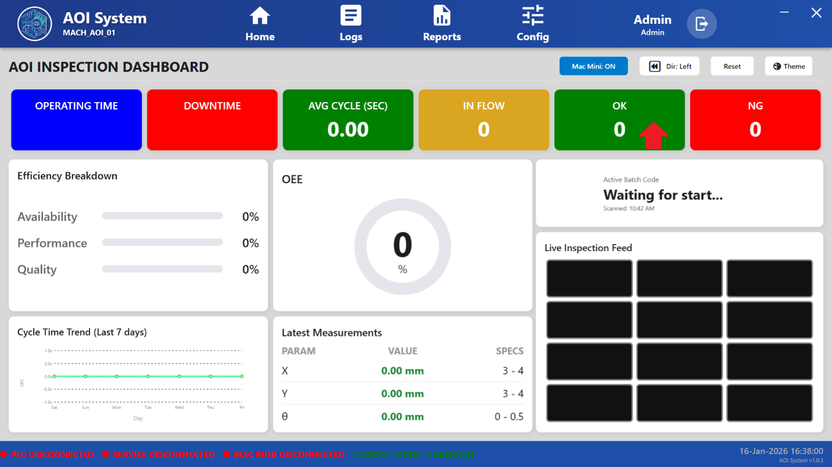

### **17.4 Displayed Information**

The Production Quality (OK) screen displays the following details:

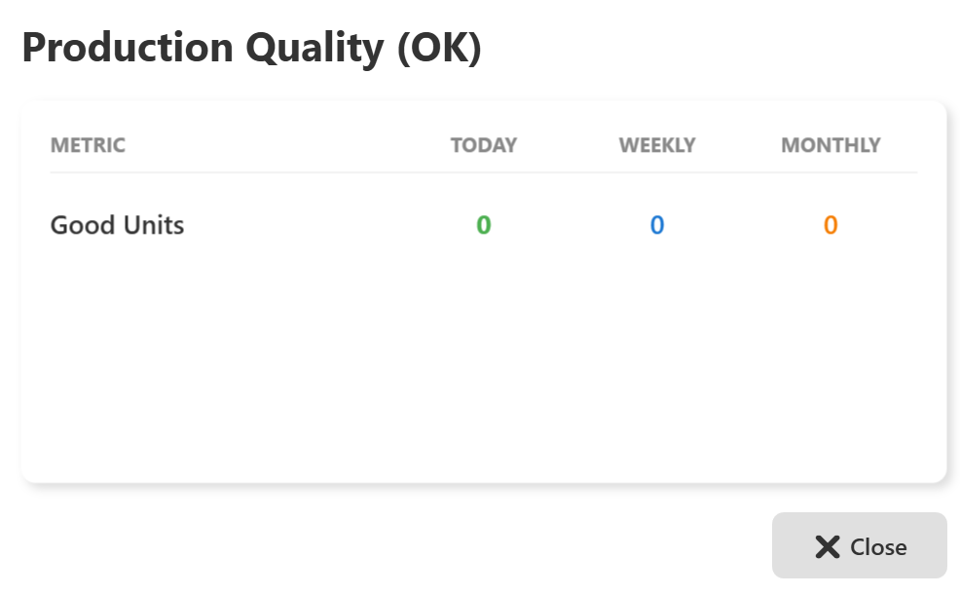

#### **17.4.1 Metric**

* **Good Units** – Represents the total number of units that have successfully passed inspection and are classified as OK.

#### **17.4.2 Today**

* Displays the total number of good units produced during the current day.
* The value resets automatically at the start of a new day.

#### **17.4.3 Weekly**

* Displays the total number of good units produced during the current week.
* Used to monitor short-term production quality trends.

#### **17.4.4 Monthly**

* Displays the total number of good units produced during the current month.
* Used for long-term quality performance analysis and reporting.

### **17.5 System Behavior**

* Good unit counts are updated automatically after each successful inspection cycle.
* Only units that pass all inspection criteria are included.
* If no inspections are completed, the values may remain **0**.

### **17.6 Operator Guidelines**

* Regularly monitor good unit counts to assess production quality.
* Compare good units with input and reject statistics for quality analysis.
* Report sudden drops or abnormal values to supervisors or quality engineers.

### **17.7 Safety and Operational Notes**

* Production Quality (OK) is a monitoring feature only.
* This screen does not allow modification of inspection results.
* Quality data should be reviewed along with reject statistics and alarms for accurate evaluation.

### **17.8 Operator Note**

Production Quality (OK) data is used for quality monitoring, reporting, and continuous improvement activities.  
Access to this screen is generally available to all authorized users.

## **18 Rejection Statistics (NG) Screen**

### **18.1 Screen Name**

**Rejection Statistics (NG)**

### **18.2 Purpose**

The Rejection Statistics (NG) screen displays the total number of units that have failed inspection and are classified as rejected (NG).  
This screen helps operators, quality engineers, and supervisors monitor rejection trends and overall inspection quality.

### **18.3 Screen Overview**

The Rejection Statistics (NG) screen is displayed when the user clicks on **NG** or **Rejection Statistics** from the Dashboard.

This screen presents rejected unit data in a summarized table format across different time periods.  
A **Close** button is provided to exit the screen and return to the previous view.

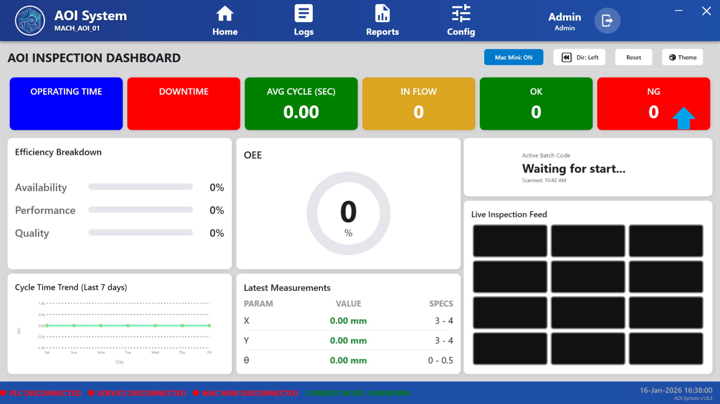

### **18.4 Displayed Information**

The Rejection Statistics (NG) screen displays the following details:

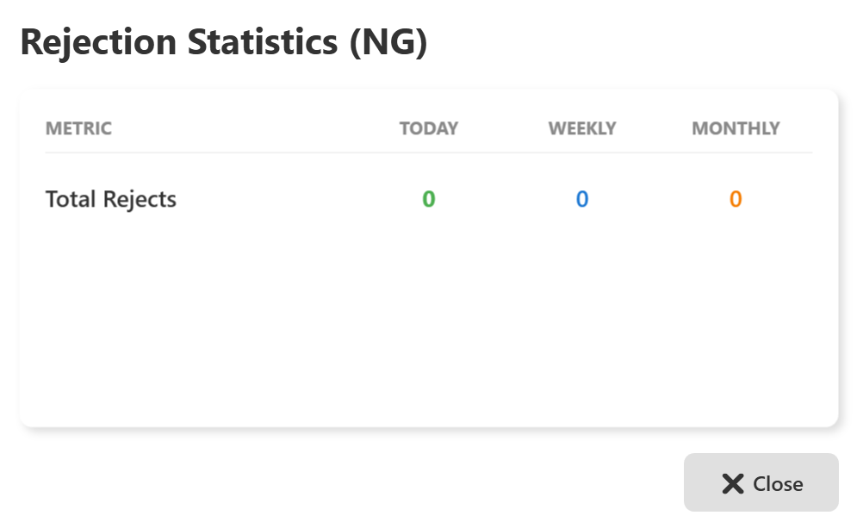

#### **18.4.1 Metric**

* **Total Rejects** – Represents the total number of units that failed inspection and were marked as NG.

#### **18.4.2 Today**

* Displays the total number of rejected units recorded during the current day.
* The value resets automatically at the start of a new day.

#### **18.4.3 Weekly**

* Displays the total number of rejected units recorded during the current week.
* Used to analyze short-term rejection trends.

#### **18.4.4 Monthly**

* Displays the total number of rejected units recorded during the current month.
* Used for long-term quality and process analysis.

### **18.5 System Behavior**

* Reject counts are updated automatically after each inspection cycle.
* Any unit that does not meet inspection criteria is included in the reject count.
* If no rejected units are detected, the values may remain **0**.

### **18.6 Operator Guidelines**

* Regularly monitor rejection statistics to identify quality issues.
* Compare reject counts with input and good unit statistics for analysis.
* Inform quality or maintenance personnel if rejection counts increase abnormally.

### **18.7 Safety and Operational Notes**

* Rejection Statistics is a monitoring and reporting feature only.
* This screen does not allow modification of inspection results.
* Reject data should be reviewed along with alarms and inspection logs for root cause analysis.

### **18.8 Operator Note**

Rejection Statistics (NG) data is critical for quality monitoring, defect analysis, and continuous improvement activities.  
Access to this screen is generally available to all authorized users.

**19 Efficiency Breakdown Details Screen**

### **19.1 Screen Name**

**Efficiency Breakdown Details**

### **19.2 Purpose**

The Efficiency Breakdown Details screen displays a detailed breakdown of machine efficiency parameters.  
It helps operators, supervisors, and management evaluate overall equipment effectiveness by analyzing availability, performance, and quality.

### **19.3 Screen Overview**

The Efficiency Breakdown Details screen is displayed when the user clicks on **Efficiency Breakdown** from the Dashboard.

This screen presents efficiency metrics in percentage (%) format for different time periods.  
A **Close** button is provided to exit the screen and return to the previous view.

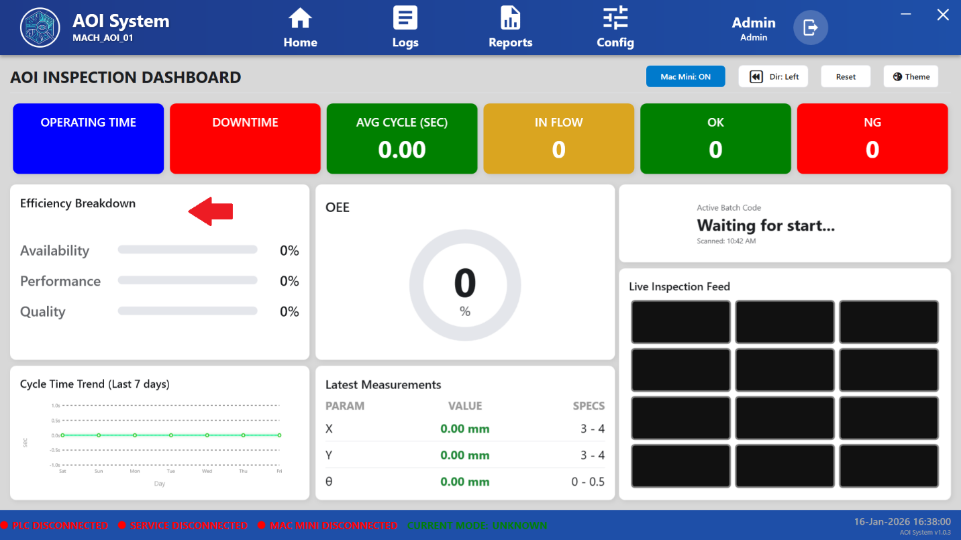

### **19.4 Displayed Information**

The Efficiency Breakdown Details screen displays the following metrics:

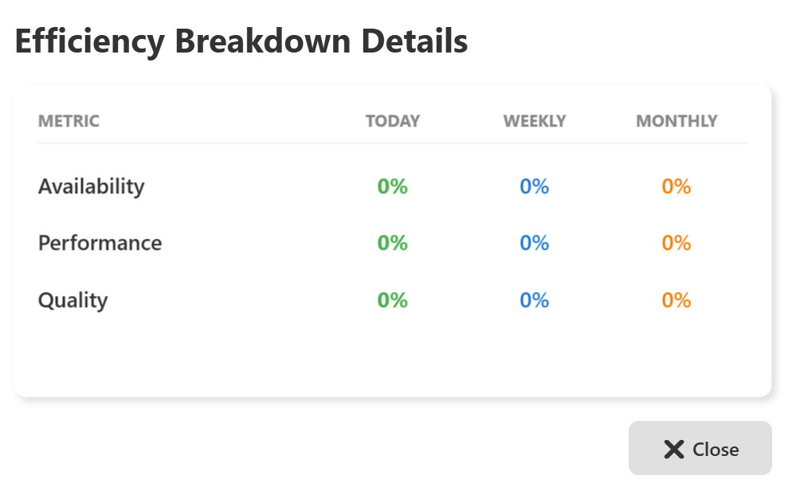

#### **19.4.1 Availability**

* Indicates the percentage of time the machine was available for operation.
* Calculated based on operating time versus total scheduled time.

#### **19.4.2 Performance**

* Indicates how efficiently the machine operated compared to its designed or expected cycle time.
* Reflects speed losses and operational inefficiencies.

#### **19.4.3 Quality**

* Indicates the percentage of good units produced compared to total inspected units.
* Calculated using accepted (OK) and rejected (NG) data.

#### **19.4.4 Today**

* Displays efficiency values calculated for the current day.

#### **19.4.5 Weekly**

* Displays efficiency values calculated for the current week.

#### **19.4.6 Monthly**

* Displays efficiency values calculated for the current month.

### **19.5 System Behavior**

* Efficiency values are calculated automatically by the system.
* Percentages are updated in real time based on operating, downtime, and inspection data.
* If insufficient data is available, values may be displayed as **0%**.

### **19.6 Operator Guidelines**

* Use efficiency data to understand overall machine performance.
* Monitor trends across daily, weekly, and monthly periods.
* Report abnormal drops in availability, performance, or quality to supervisors or maintenance teams.

### **19.7 Safety and Operational Notes**

* Efficiency Breakdown is a monitoring and analysis feature only.
* This screen does not allow any modification of machine parameters.
* Efficiency data should be reviewed along with Operating Time, Downtime, and Quality statistics for accurate analysis.

### **19.8 Operator Note**

Efficiency Breakdown Details support productivity analysis, performance optimization, and continuous improvement initiatives.  
Access to this screen is generally available to all authorized users.

## **20 OEE Score Statistics Screen**

### **20.1 Screen Name**

**OEE Score Statistics**

### **20.2 Purpose**

The OEE Score Statistics screen displays the Overall Equipment Effectiveness (OEE) score of the AOI system.  
This screen provides a single, consolidated performance indicator representing the effectiveness of machine operation.

### **20.3 Screen Overview**

The OEE Score Statistics screen is displayed when the user clicks on **OEE** from the Dashboard.

This screen presents the OEE score in percentage (%) format for different time periods.  
A **Close** button is provided to exit the screen and return to the previous view.

### **20.4 Displayed Information**

The OEE Score Statistics screen displays the following information:

#### **20.4.1 Metric**

* **OEE Score** – Represents the overall efficiency of the machine, calculated as a combination of:
  + Availability
  + Performance
  + Quality

#### **20.4.2 Today**

* Displays the OEE score calculated for the current day.
* Reflects real-time operational efficiency.

#### **20.4.3 Weekly**

* Displays the OEE score calculated for the current week.
* Used to analyze short-term efficiency trends.

#### **20.4.4 Monthly**

* Displays the OEE score calculated for the current month.
* Used for long-term performance analysis and management reporting.

### **20.5 System Behavior**

* OEE values are calculated automatically by the system.
* The score is updated dynamically based on availability, performance, and quality data.
* If sufficient data is not available, the OEE score may be displayed as **0%**.

### **20.6 Operator Guidelines**

* Monitor OEE score regularly to understand overall machine performance.
* Compare daily, weekly, and monthly values to identify efficiency trends.
* Report sudden or consistent drops in OEE score to supervisors or maintenance teams.

### **20.7 Safety and Operational Notes**

* OEE Score Statistics is a monitoring and analysis feature only.
* This screen does not allow modification of machine parameters or operation.
* OEE data should be reviewed along with downtime, cycle time, and quality statistics for accurate assessment.

### **20.8 Operator Note**

OEE Score Statistics provide a high-level indicator of machine effectiveness and are commonly used for productivity analysis, reporting, and continuous improvement initiatives.  
Access to this screen is generally available to all authorized users.

## 

## **21 PLC I/O Monitor Screen**

### **21.2 Purpose**

The PLC I/O Monitor screen provides real-time visibility of PLC input and output signals.  
This screen helps operators, maintenance engineers, and administrators monitor machine signals and verify PLC communication status.

### **21.3 Screen Overview**

The PLC I/O Monitor screen is displayed when the user selects **PLC IO** from the left navigation menu.

This screen displays PLC signal information in a tabular format and allows the user to switch between **Inputs** and **Outputs** views.

A search field is provided to quickly locate specific signals.

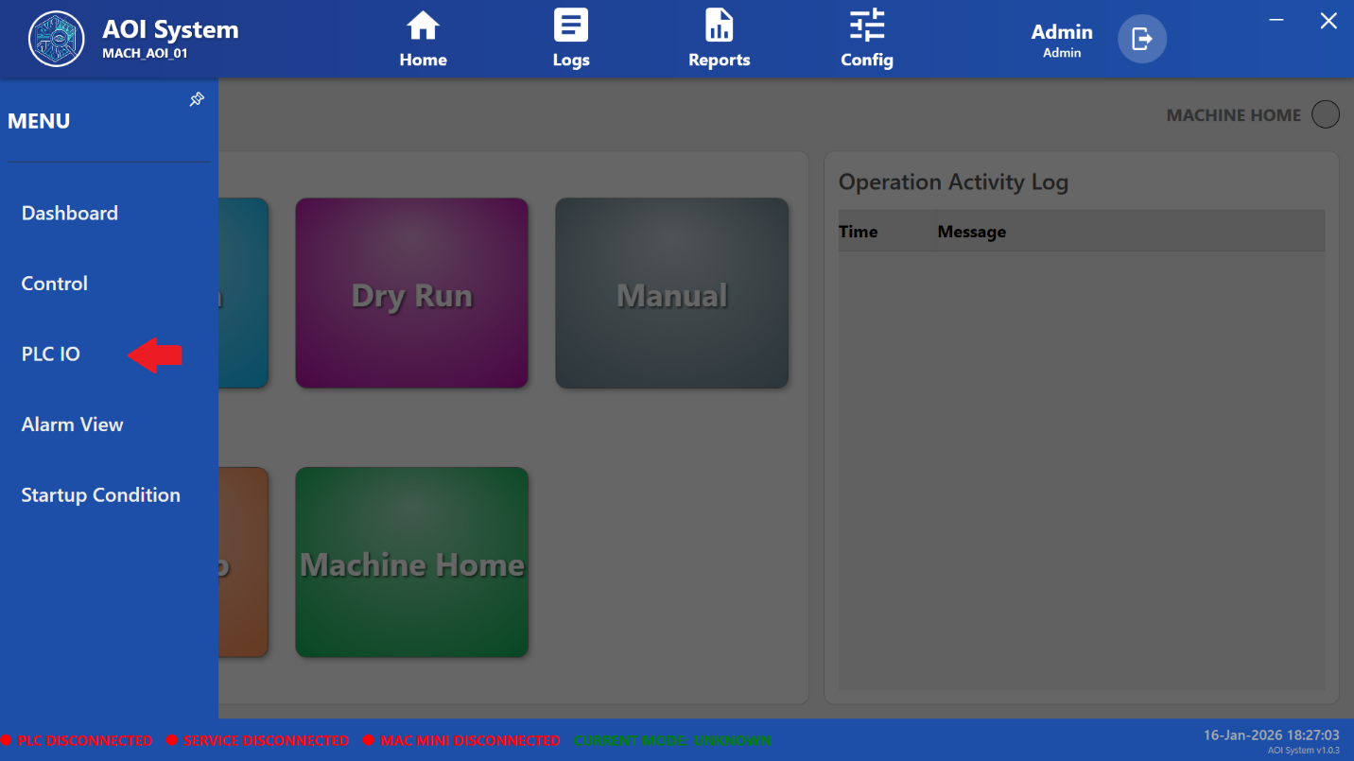

### **21.4 Screen Layout Description**

The PLC I/O Monitor screen consists of the following main elements:

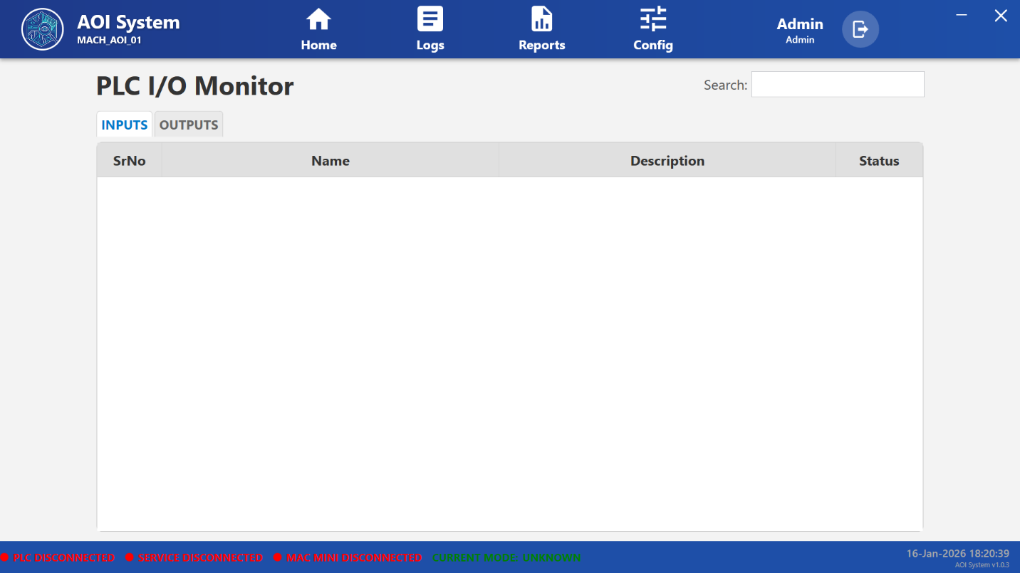

#### **21.4.1 Inputs Tab**

* Displays all PLC input signals.
* Used to monitor sensors, switches, and incoming signals from the machine.
* Each input reflects its real-time status.

#### **21.4.2 Outputs Tab**

* Displays all PLC output signals.
* Used to monitor actuators, relays, and machine control outputs.
* Shows the current output state sent by the PLC.

#### **21.4.3 Signal Table Columns**

Each signal is displayed with the following details:

• **Sr No** – Sequential number of the signal  
• **Name** – PLC tag or signal name  
• **Description** – Functional description of the signal  
• **Status** – Current state of the signal (ON / OFF)

#### **21.4.4 Search Field**

* Allows searching PLC signals by name or description.
* Helps quickly locate specific inputs or outputs.

### **21.5 System Behavior**

* PLC I/O status is updated automatically in real time.
* Signal status changes instantly based on PLC communication.
* If PLC communication is lost, signal data may not update.

### **21.6 Operator Guidelines**

* Use PLC I/O Monitor for observation and verification only.
* Do not rely on this screen alone for troubleshooting without proper authorization.
* Inform maintenance personnel if signal behavior does not match expected operation.

### **21.7 Safety and Operational Notes**

* PLC I/O Monitor is a monitoring screen only.
* Operators must not attempt to modify PLC logic or wiring.
* Access to this screen may be restricted based on user role.

### **21.8 Operator Note**

PLC I/O monitoring is primarily intended for diagnostics, troubleshooting, and verification purposes.  
Configuration changes must be performed only by authorized personnel.

## **22 Alarm View Screen**

### **22.1 Screen Name**

**Alarms View**

### **22.2 Purpose**

The Alarm View screen displays all system-generated alarms related to machine operation, safety, and system faults.  
This screen helps operators and maintenance personnel identify abnormal conditions and take appropriate corrective actions.

### **22.3 Screen Overview**

The Alarm View screen is displayed when the user selects **Alarm View** from the left navigation menu.

This screen presents alarm information in a tabular format, along with controls to view, filter, and reset alarms.

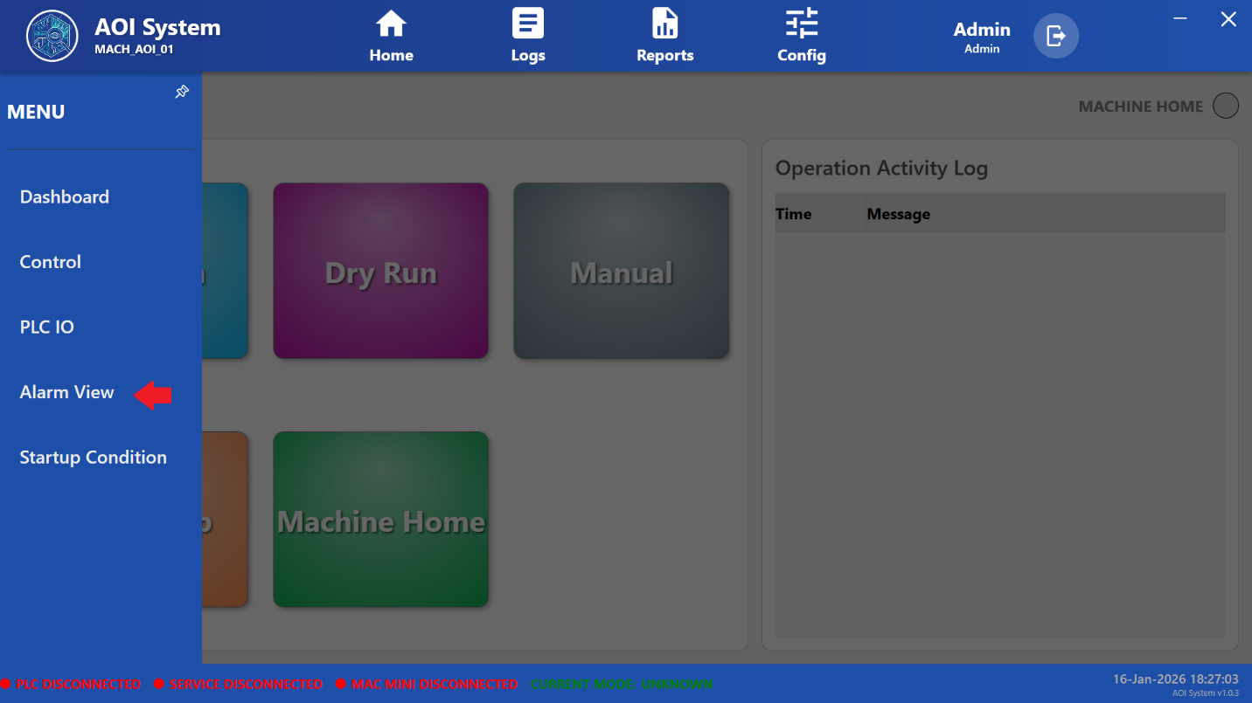

### **22.4 Screen Layout Description**

The Alarm View screen consists of the following elements:

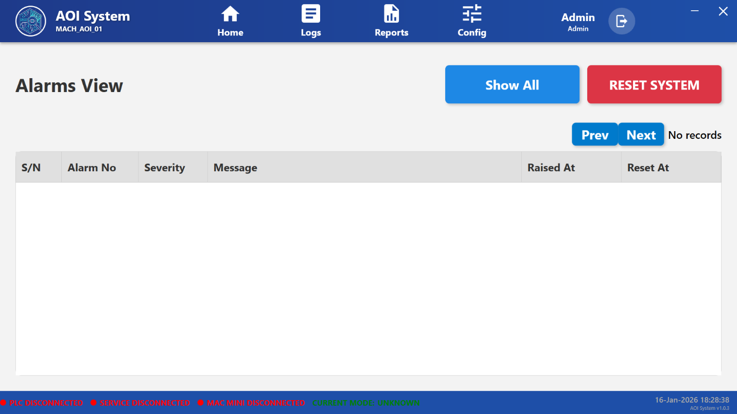

#### **22.4.1 Alarm List Table**

Each alarm entry is displayed with the following details:

• **S/N** – Sequential number of the alarm  
• **Alarm No** – Unique alarm identification number  
• **Severity** – Alarm severity level (e.g., Warning, Critical)  
• **Message** – Description of the alarm condition  
• **Raised At** – Date and time when the alarm was triggered  
• **Reset At** – Date and time when the alarm was cleared

#### **22.4.2 Show All Button**

* Displays all alarms, including active and historical alarms.
* Used to review past alarm occurrences.

#### **22.4.3 Reset System Button**

* Used to reset the system after alarms are cleared.
* Typically available only to authorized users.
* Should be used only after the root cause of the alarm has been resolved.

#### **22.4.4 Navigation Controls**

* **Prev / Next** buttons are used to navigate through multiple pages of alarm records.
* Displays “No records” when no alarms are present.

### **22.5 System Behavior**

* Alarms are generated automatically based on system conditions.
* Active alarms remain visible until the fault is resolved and the alarm is reset.
* Alarm timestamps are recorded for traceability and audit purposes.

### **22.6 Operator Guidelines**

* Always review alarm messages carefully before taking action.
* Do not reset alarms without resolving the underlying issue.
* Inform maintenance or engineering personnel for critical or repeated alarms.

### **22.7 Safety and Operational Notes**

* Ignoring alarms may lead to unsafe machine operation.
* Do not use **Reset System** as a substitute for proper fault correction.
* Follow company-defined alarm handling and escalation procedures.

### **22.8 Operator Note**

Alarm View is a critical diagnostic and safety screen.  
Only authorized personnel should perform system resets after alarms are cleared.

## **23 Startup Conditions Screen**

### **23.1 Screen Name**

**Startup Conditions**

### **23.2 Purpose**

The Startup Conditions screen is used to verify that all mandatory system and machine conditions are satisfied before starting any operation.  
This screen ensures the AOI system is in a safe and ready state for Auto Run or Dry Run operations.

### **23.3 Screen Overview**

The Startup Conditions screen is displayed when the user selects **Startup Condition** from the left navigation menu.

This screen performs a system readiness check and displays the overall startup status.  
A confirmation indicator is shown at the bottom of the screen once all conditions are satisfied.

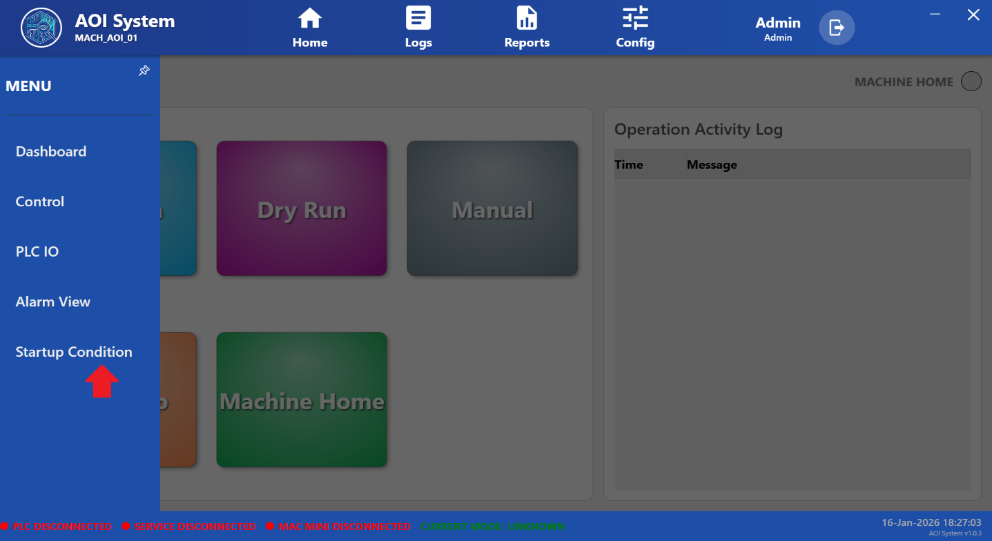

### **23.4 Displayed Information**

The Startup Conditions screen provides the following information:

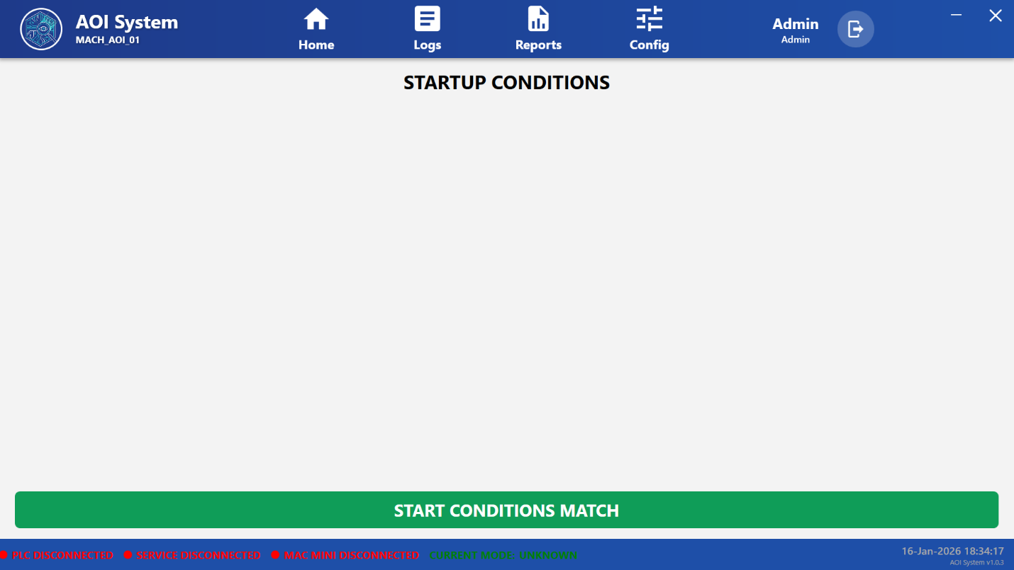

#### **23.4.1 Startup Status**

* Displays the overall readiness of the system.
* Indicates whether all required startup conditions are met.

#### **23.4.2 Start Conditions Match Indicator**

* A green status bar labeled **“START CONDITIONS MATCH”** is displayed when:
  + All system checks pass successfully
  + No blocking alarms or errors are present
  + The machine is ready for operation

### **23.5 System Behavior**

* Startup conditions are evaluated automatically by the system.
* The system continuously monitors required parameters.
* If any condition fails, the startup confirmation is not displayed.

### **23.6 Operator Guidelines**

* Always verify Startup Conditions before starting Auto Run or Dry Run.
* Do not attempt to start machine operation if startup conditions are not satisfied.
* Resolve any alarms, errors, or disconnected statuses before proceeding.

### **23.7 Safety and Operational Notes**

* Startup Conditions act as a safety gate for machine operation.
* Ignoring startup readiness may lead to unsafe operation or system faults.
* Only proceed when **START CONDITIONS MATCH** is clearly displayed.

### **23.8 Operator Note**

Startup Conditions verification is mandatory before initiating production or inspection cycles.  
If startup conditions fail repeatedly, contact maintenance or engineering personnel for support.

**24 Logs Screen**

### **24.1 Screen Name**

**Logs**

### **24.2 Purpose**

The Logs screen provides access to system-generated records related to user activities, errors, and diagnostic events.  
It helps operators, maintenance engineers, and administrators monitor system history, trace events, and perform troubleshooting.

### **24.3 Screen Overview**

The Logs screen is displayed when the user clicks on **Logs** from the top navigation bar.

Upon selection:

* A left-side log navigation menu appears.
* The current operational screen remains visible in the background.
* Different categories of logs can be accessed from the menu.

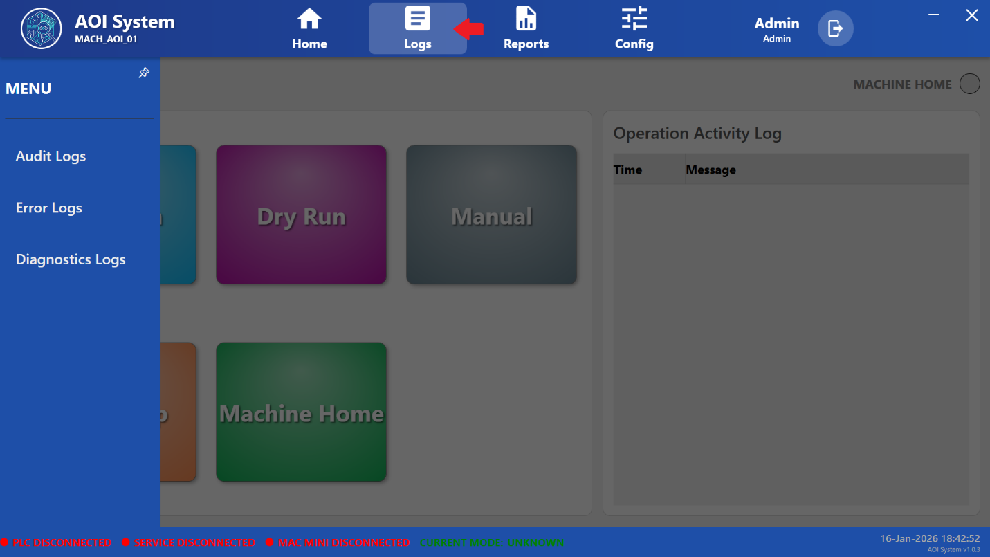

### **24.4 Log Categories**

The Logs screen provides the following log categories:

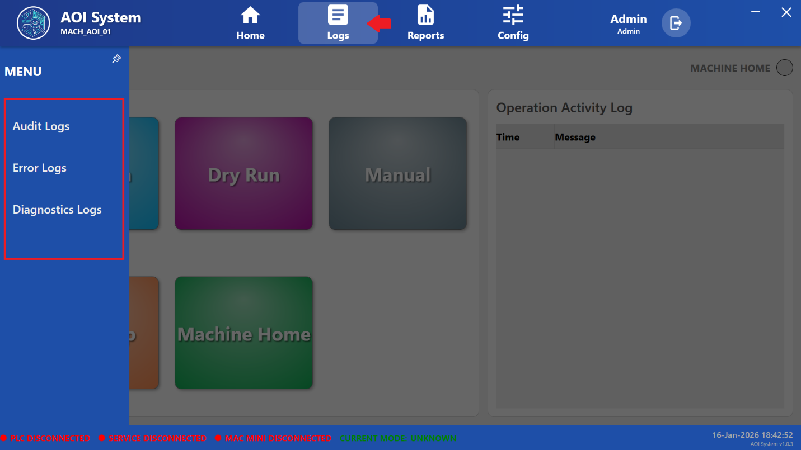

#### **24.4.1 Audit Logs**

* Records user actions and system operations.
* Used to track operator and administrator activities.
* Helps maintain traceability and compliance.

**Typical entries include:**  
• Login and logout events  
• Mode changes (Auto Run, Dry Run, Manual)  
• System configuration actions

#### **24.4.2 Error Logs**

* Displays system and application errors.
* Used to identify faults affecting system performance or operation.
* Primarily reviewed by maintenance or engineering personnel.

**Typical entries include:**  
• Service failures  
• Communication errors  
• Application exceptions

#### **24.4.3 Diagnostics Logs**

* Contains detailed diagnostic and internal system messages.
* Used for advanced troubleshooting and analysis.
* Helpful during service and debugging activities.

### **24.5 System Behavior**

* Logs are recorded automatically by the system.
* Entries are time-stamped for traceability.
* Log data is stored securely and cannot be modified by operators.

### **24.6 Operator Guidelines**

* Operators should use logs only for review and reference.
* Do not attempt to clear or modify logs unless authorized.
* Inform maintenance personnel if repeated or critical errors are observed.

### **24.7 Safety and Operational Notes**

* Logs are informational and diagnostic in nature.
* Do not ignore recurring error or diagnostic messages.
* Follow company-defined procedures for log review and escalation.

### **24.8 Operator Note**

Access to specific log categories may vary based on user role.  
Administrative or engineering access may be required for detailed diagnostics.

**25 Audit Logs Screen**

### **25.1 Screen Name**

**Audit Logs**

### **25.2 Purpose**

The Audit Logs screen provides a detailed record of user activities and operational actions performed within the AOI system.  
This screen ensures traceability, accountability, and compliance with system usage policies.

### **25.3 Screen Overview**

The Audit Logs screen is displayed when the user selects **Audit Logs** from the Logs menu.

The screen is divided into two main sections:

• File List Panel (Left)  
• File Content View Panel (Right)

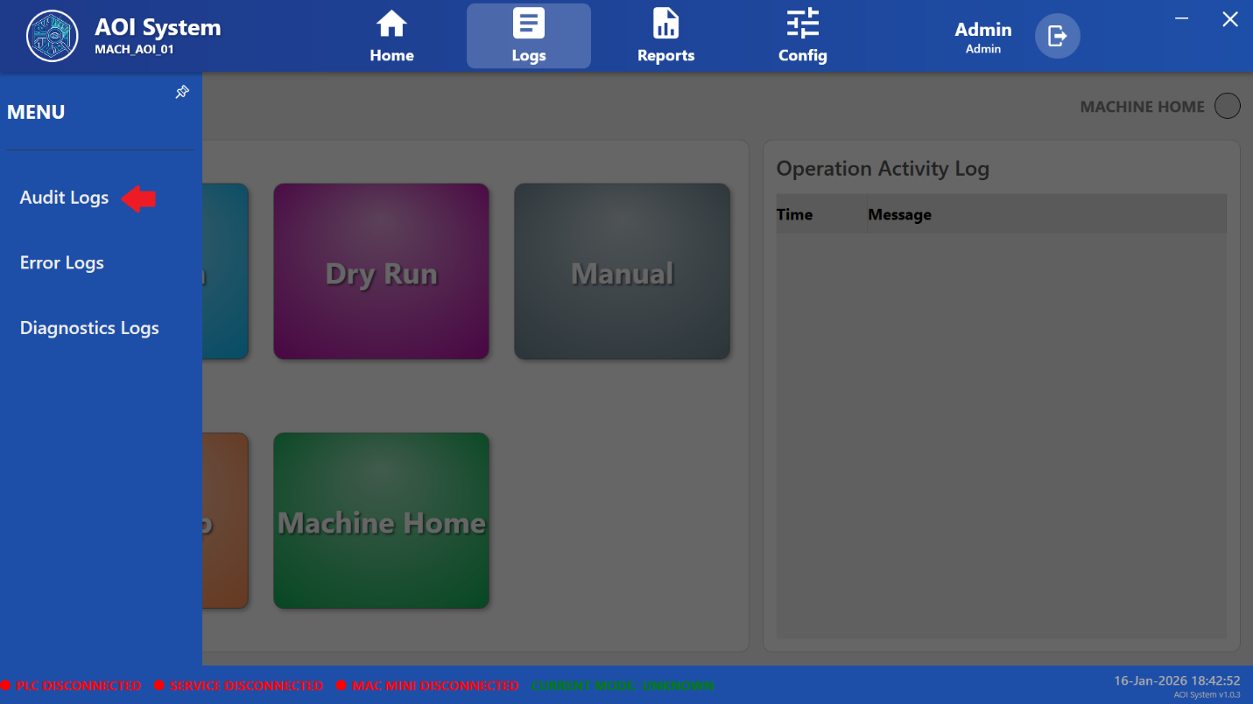

### **25.4 File List Panel**

**Purpose:**  
Displays available audit log files generated by the system.

**Displayed Information:**  
• Log file name (e.g., Audit_{YYYYMMDD}.csv)  
• Last modified date and time

**Operator Action:**  
• Select a log file to view its contents  
• Click **Refresh Files** to reload the available log files

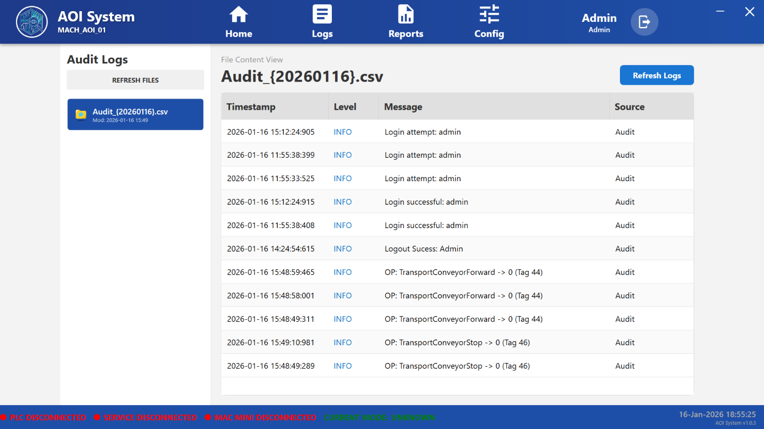

### **25.5 File Content View Panel**

**Purpose:**  
Displays the contents of the selected audit log file in tabular format.

**Displayed Columns:**

• **Timestamp** – Date and time when the event occurred  
• **Level** – Severity or information level of the event  
• **Message** – Description of the user or system action  
• **Source** – Origin of the log entry (Audit module)

### **25.6 Logged Activities**

Audit Logs typically record the following activities:

• User login attempts  
• Successful and failed login events  
• User logout events  
• Operator actions (e.g., conveyor start/stop, machine operations)  
• Mode changes and operational commands

### **25.7 System Behavior**

• Audit logs are generated automatically by the system  
• Logs are stored in CSV format for easy review and export  
• Entries are recorded in chronological order  
• Audit logs cannot be edited or deleted by operators

### **25.8 Operator Guidelines**

• Use audit logs only for review and verification purposes  
• Do not attempt to modify log files  
• Report any abnormal or unauthorized activity to the supervisor or administrator

### **25.9 Administrator Notes**

• Audit logs are critical for compliance and traceability  
• Logs may be reviewed during audits or investigations  
• Administrative privileges may be required for advanced log management

### **25.10 Important Notes**

• Audit Logs reflect actual system and user activities  
• Any discrepancy in logs should be escalated immediately  
• Logs help in identifying misuse, errors, or abnormal operations

## **26 Error Logs Screen**

### **26.1 Screen Name**

**Error Logs**

### **26.2 Purpose**

The Error Logs screen is used to record and display system errors, failures, and abnormal events that occur during operation.  
This screen helps in identifying issues related to user actions, system services, or communication failures.

### **26.3 Screen Overview**

The Error Logs screen is displayed when the user selects **Error Logs** from the Logs menu.

The screen is divided into two sections:

• File List Panel (Left)  
• File Content View Panel (Right)

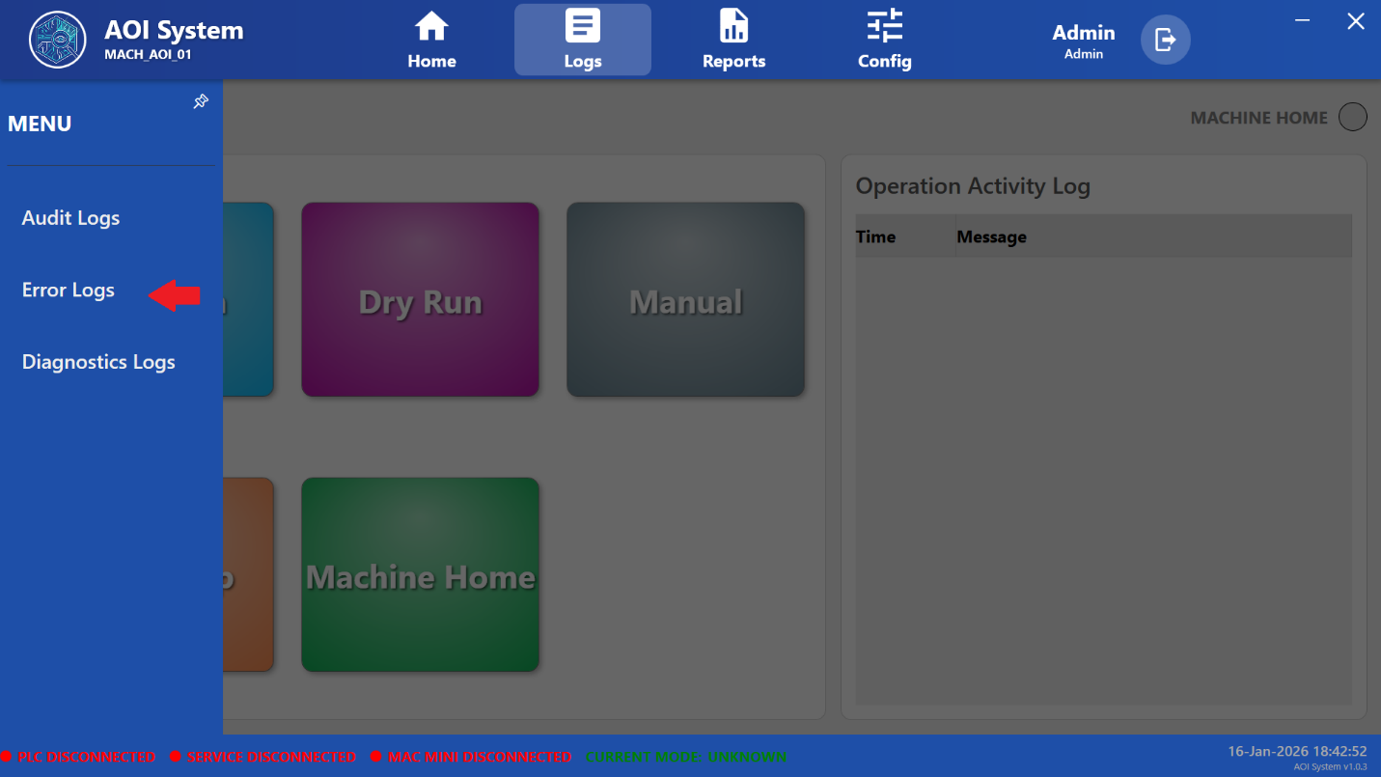

### **26.4 File List Panel**

**Purpose:**  
Displays available error log files generated by the system.

**Displayed Information:**  
• Error log file name (e.g., Error_{YYYYMMDD}.csv)  
• File last modified date and time

**Operator / Administrator Action:**  
• Select an error log file to view its contents  
• Click **Refresh Files** to reload the list of available error log files

### **26.5 File Content View Panel**

**Purpose:**  
Displays the contents of the selected error log file in a tabular format.

**Displayed Columns:**

• **Timestamp** – Date and time when the error occurred  
• **Level** – Severity level of the event (ERROR)  
• **Message** – Description of the error condition  
• **Source** – Origin of the error (Error module)

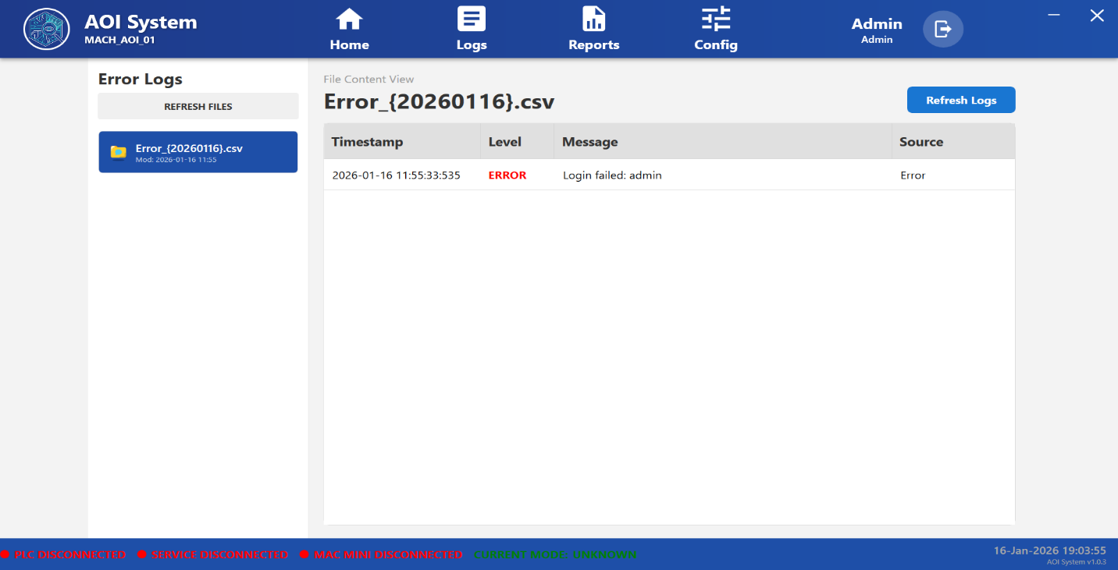

### **26.6 Typical Error Entries**

Error Logs may include the following types of events:

• Failed login attempts  
• Unauthorized access attempts  
• System or service failures  
• Communication errors (PLC, Vision System, Core Service)  
• Critical operation failures

### **26.7 System Behavior**

• Error logs are generated automatically by the system  
• Logs are stored in CSV format for traceability and review  
• Entries are recorded with accurate timestamps  
• Error logs cannot be modified or deleted by operators

### **26.8 Operator Guidelines**

• Review error logs when abnormal system behavior is observed  
• Do not attempt repeated actions if errors persist  
• Inform maintenance or engineering personnel if critical errors appear

### **26.9 Administrator Notes**

• Error logs are essential for troubleshooting and root cause analysis  
• Logs may be used during audits or failure investigations  
• Administrative access may be required for corrective actions

### **26.10 Important Notes**

• Error Logs reflect actual system error conditions  
• Repeated errors indicate unresolved system issues  
• Immediate action is recommended for critical or recurring errors

## **27 Diagnostics Logs Screen**

### **27.1 Screen Name**

**Diagnostics Logs**

### **27.2 Purpose**

The Diagnostics Logs screen is used to monitor detailed diagnostic information related to system health, internal processes, communication status, and background operations of the AOI system.  
This screen is primarily intended for troubleshooting and system analysis.

### **27.3 Screen Overview**

The Diagnostics Logs screen is displayed when the user selects **Diagnostics Logs** from the Logs menu.

The screen is divided into two main sections:

• Diagnostics File List Panel (Left)  
• File Content View Panel (Right)

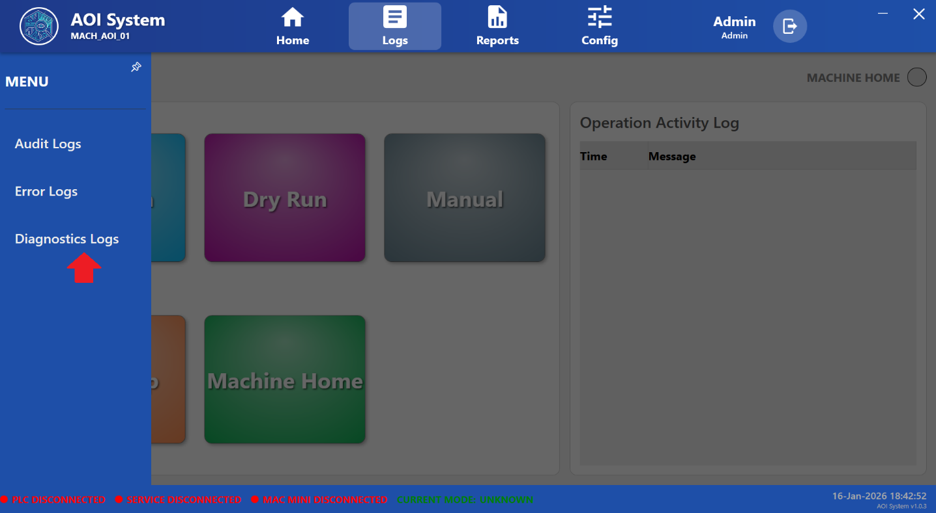

### **27.4 Diagnostics File List Panel**

**Purpose:**  
Displays the list of available diagnostics log files generated by the system.

**Displayed Information:**  
• Diagnostics log file name (e.g., Diagnostics_{YYYYMMDD}.csv)  
• File last modified date and time

**User Actions:**  
• Select a diagnostics log file to view its contents  
• Click **Refresh Files** to reload the list of available log files

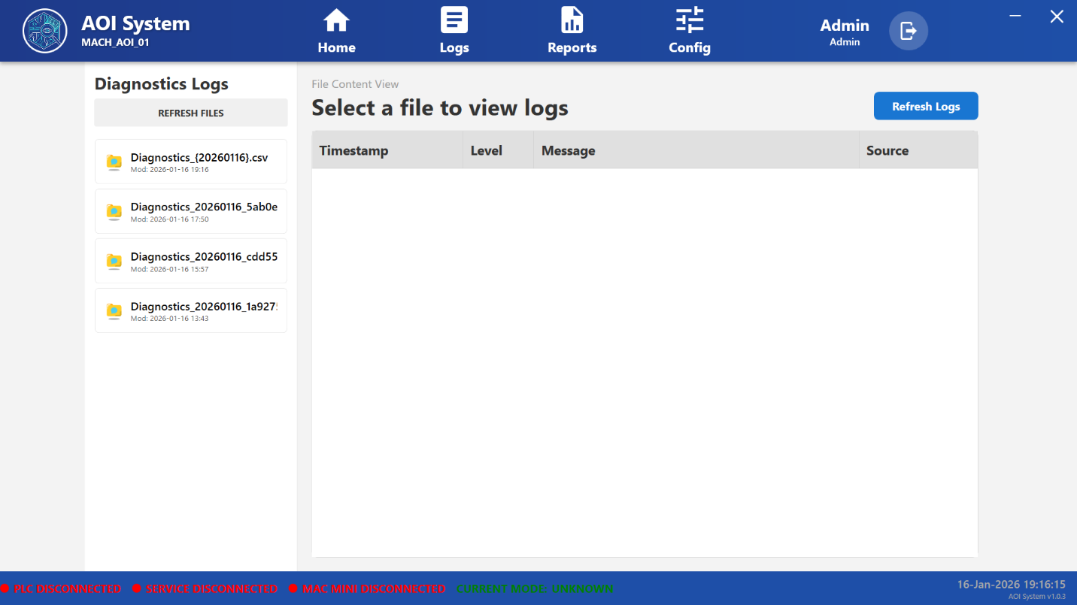

### **27.5 File Content View Panel**

**Purpose:**  
Displays the contents of the selected diagnostics log file.

**Default Behavior:**  
• When no file is selected, the message **“Select a file to view logs”** is displayed  
• Log data appears only after a file is selected

**Displayed Columns:**

• **Timestamp** – Date and time of the diagnostic event  
• **Level** – Log severity level (INFO / WARNING / ERROR)  
• **Message** – Diagnostic description or system message  
• **Source** – Module or subsystem generating the log

### **27.6 Typical Diagnostic Events**

Diagnostics logs may contain information related to:

• System startup and shutdown sequences  
• Service initialization and health checks  
• PLC communication status  
• Vision system connectivity  
• Background task execution  
• Performance or latency monitoring

### **27.7 System Behavior**

• Diagnostics logs are generated automatically by the system  
• Files are stored in CSV format for analysis and traceability  
• Logs are read-only and cannot be modified by the user  
• Multiple diagnostic files may be generated in a single day

### **27.8 Operator Guidelines**

• Operators may view diagnostics logs only for monitoring purposes  
• No corrective actions should be taken without proper authorization  
• Report abnormal or repeated diagnostic warnings to maintenance staff

### **27.9 Administrator Notes**

• Diagnostics logs are critical for advanced troubleshooting  
• Used by service engineers for fault isolation and system analysis  
• Recommended to review diagnostics logs before performing system resets

### **27.10 Important Notes**

• Diagnostics logs provide internal system-level information  
• These logs are not intended for normal production monitoring  
• Administrative or engineering knowledge may be required to interpret entries

## **28 Reports Module**

### **28.1 Screen Name**

**Reports**

### **28.2 Purpose**

The Reports module allows users to view, analyze, and retrieve production-related data and inspection images generated by the AOI system.  
This module supports performance analysis, quality tracking, and traceability.

### **28.3 Screen Overview**

When the user clicks on **Reports** from the top menu bar, a left-side menu is displayed with the following options:

• Production Data  
• Production Images

Based on the selected option, the corresponding report screen is displayed in the main display area.

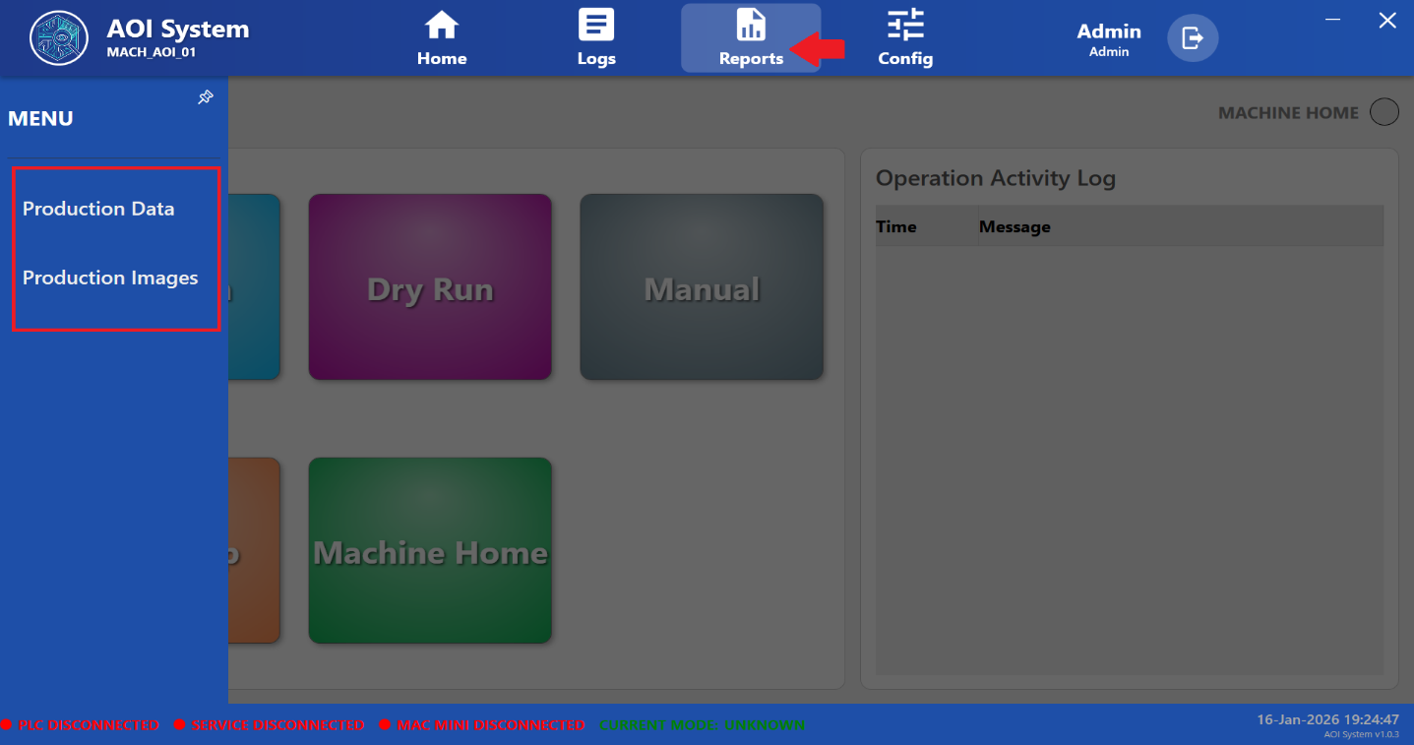

## **28.4 Production Data**

### **28.4.1 Screen Name**

Production Data

### **28.4.2 Purpose**

The Production Data screen provides numerical and statistical information related to production output generated by the AOI system.  
This data is used for monitoring, reporting, and analysis purposes.

### **28.4.3 Screen Overview**

This screen displays production-related data collected during system operation in a structured and readable format.  
The information helps users review production performance over a selected period.

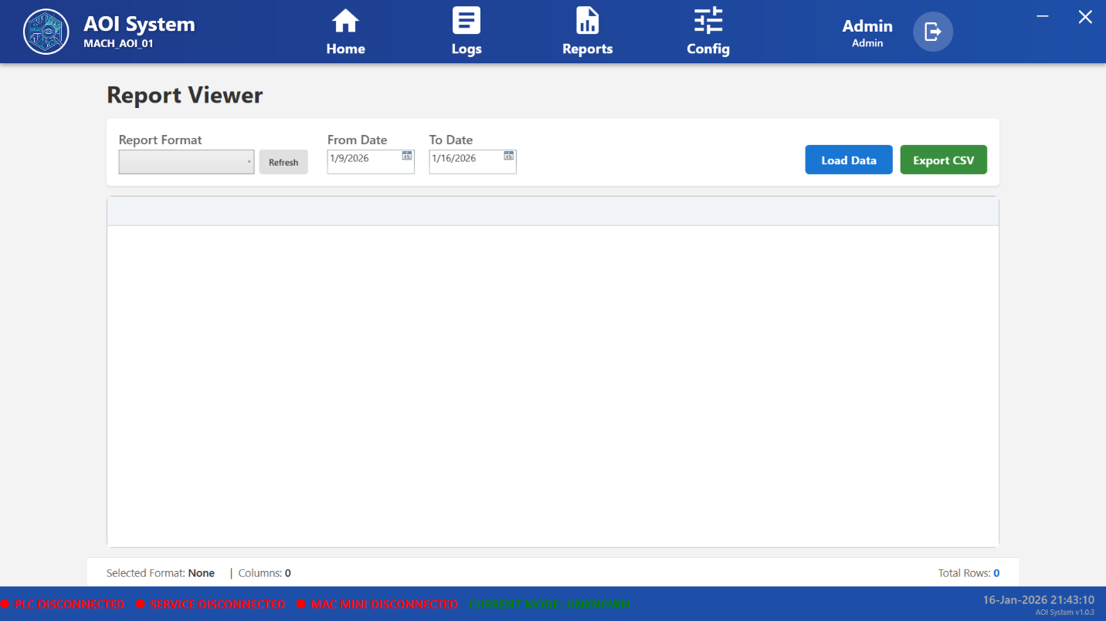

### **28.4.4 Displayed Information**

Production Data may include:  
• Total input count  
• Good (OK) units count  
• Rejected (NG) units count  
• Average cycle time information  
• Efficiency and OEE-related values

(Data availability depends on selected report type and available production records.)

### **28.4.5 Operator Guidelines**

• Use this screen for viewing and monitoring production reports  
• All displayed data is system-generated and read-only  
• Report any data inconsistency to the authorized team

## **28.6 Production Images**

### **28.6.1 Screen Name**

Production Images

### **28.6.2 Purpose**

The Production Images screen allows users to view inspection images captured by the vision system and stored as part of production records.

### **28.6.3 Screen Overview**

This screen displays inspection images in a folder-based structure for easy navigation and review.  
Images are provided for reference and quality verification.

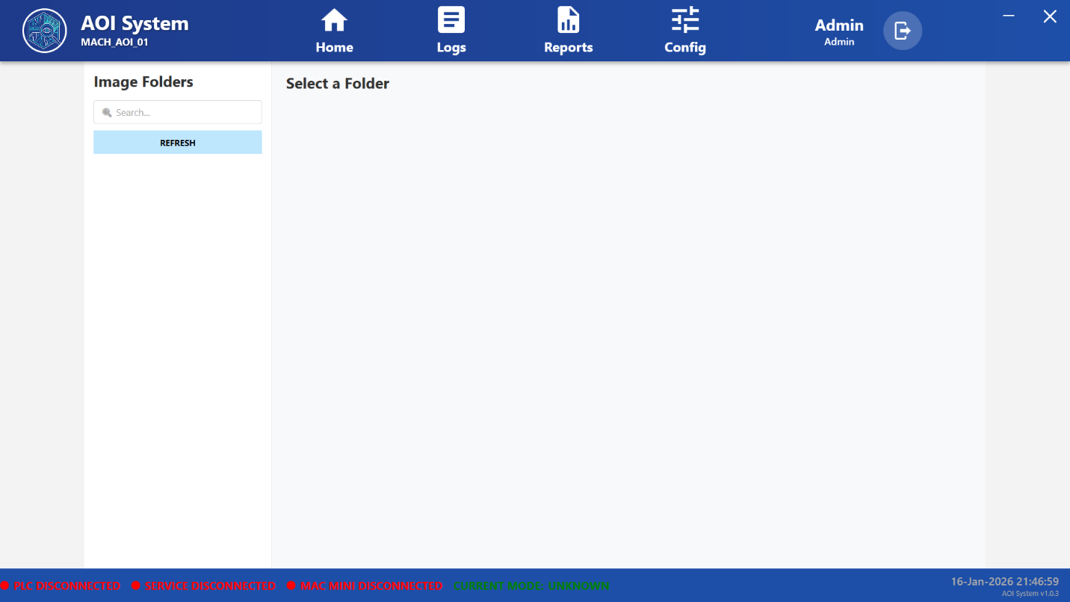

### **28.6.4 Displayed Information**

Production Images may include:  
• Inspection images captured during production  
• Folder-wise image organization  
• Time or batch-based image grouping (if configured)

### **28.6.5 Operator Guidelines**

• Images are provided for viewing and verification only  
• Do not delete, modify, or move images without authorization  
• Use images to support quality review and reporting

## **28.7 Report Behavior**

• Production reports and images are generated automatically by the system  
• Report data and images are stored as per system configuration  
• Viewing reports does not affect ongoing system operation

**29 Configuration Menu Overview**

### **29.1 Screen Name**

Configuration Menu

### **29.2 Purpose**

The Configuration Menu provides access to system-level settings required for configuring, monitoring, and maintaining the AOI system.  
This section is primarily intended for **administrators and authorized personnel**.

### **29.3 Screen Overview**

When the user clicks on the **Config** option from the top navigation bar, a configuration side menu is displayed on the left side of the screen.  
This menu contains multiple configuration options related to system setup, control parameters, logging, reporting, and external interfaces.

Access to configuration options depends on the **logged-in user role**:

* **Operator** – Limited or view-only access
* **Admin** – Full configuration and control access

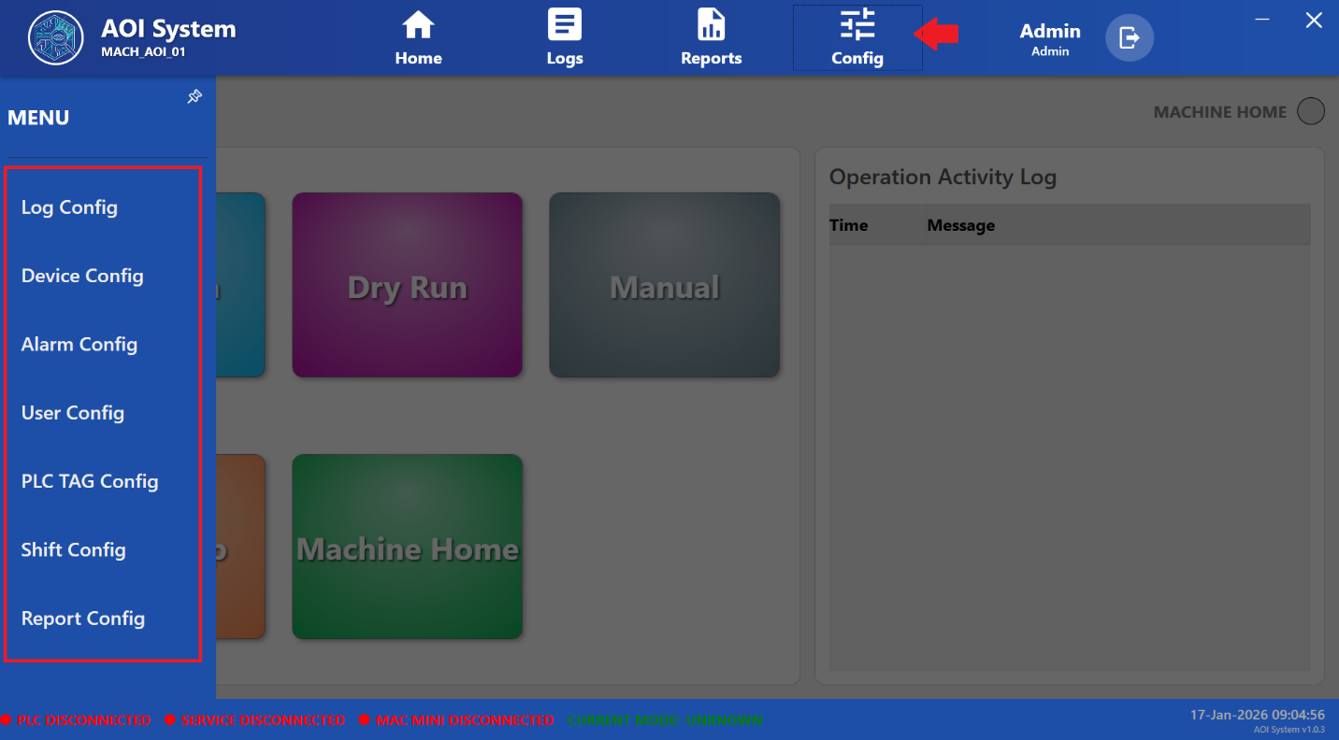

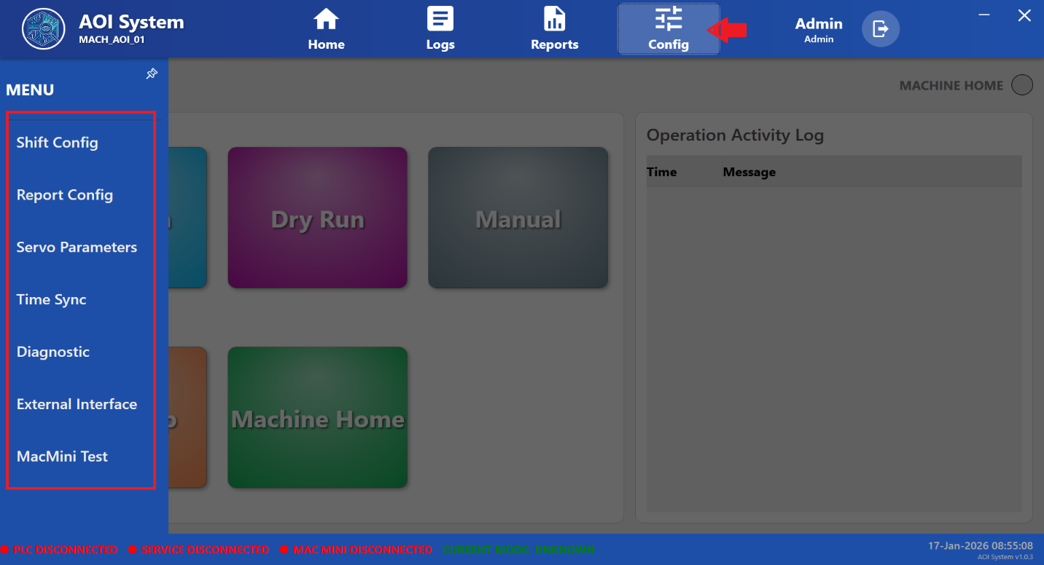

## **29.4 Available Configuration Menu Options**

The following options are available under the Configuration menu:

### **29.4.1 Log Config**

Used to configure system logging behavior, including audit, error, and diagnostic logs.

### **29.4.2 Device Config**

Used to configure hardware devices connected to the AOI system.

### **29.4.3 Alarm Config**

Allows configuration of alarm definitions, severity levels, and alarm handling behavior.

### **29.4.4 User Config**

Used to manage system users and assign roles such as Operator or Admin.

### **29.4.5 PLC TAG Config**

Used to configure PLC tag mappings for proper communication between the AOI software and PLC hardware.

### **29.4.6 Shift Config**

Used to define production shift timings for accurate production tracking.

### **29.4.7 Report Config**

Used to configure report formats and select data fields for report generation.

### **29.4.8 Servo Parameters**

Allows configuration of servo control parameters used for machine motion.

### **29.4.9 Time Sync**

Used to synchronize system time across all connected components.

### **29.4.10 Diagnostic**

Provides access to diagnostic tools and system health information.

### **29.4.11 External Interface**

Used to configure communication with external systems or third-party interfaces.

### **29.4.12 MacMini Test**

Used to test connectivity and functionality of the vision system (Mac Mini).

## **29.5 Important Notes**

* Configuration access is restricted to authorized users
* Incorrect settings may impact system performance or safety
* Operators should not modify configuration values without approval
* Administrative privileges are required for critical changes

30 Log Configuration

### **30.1 Screen Name**

Log Configuration

### **30.2 Purpose**

The Log Configuration screen is used to configure and manage different types of system logs generated by the AOI system.  
This screen allows administrators to define log storage paths and control automatic log maintenance behavior.

### **30.3 Screen Overview**

When the user selects **Log Config** from the Configuration menu, the system displays a list of available log types in a tabular format.

Each row represents a specific log category along with its storage details and maintenance settings.

This screen is accessible only to **authorized users (Admin role)**.

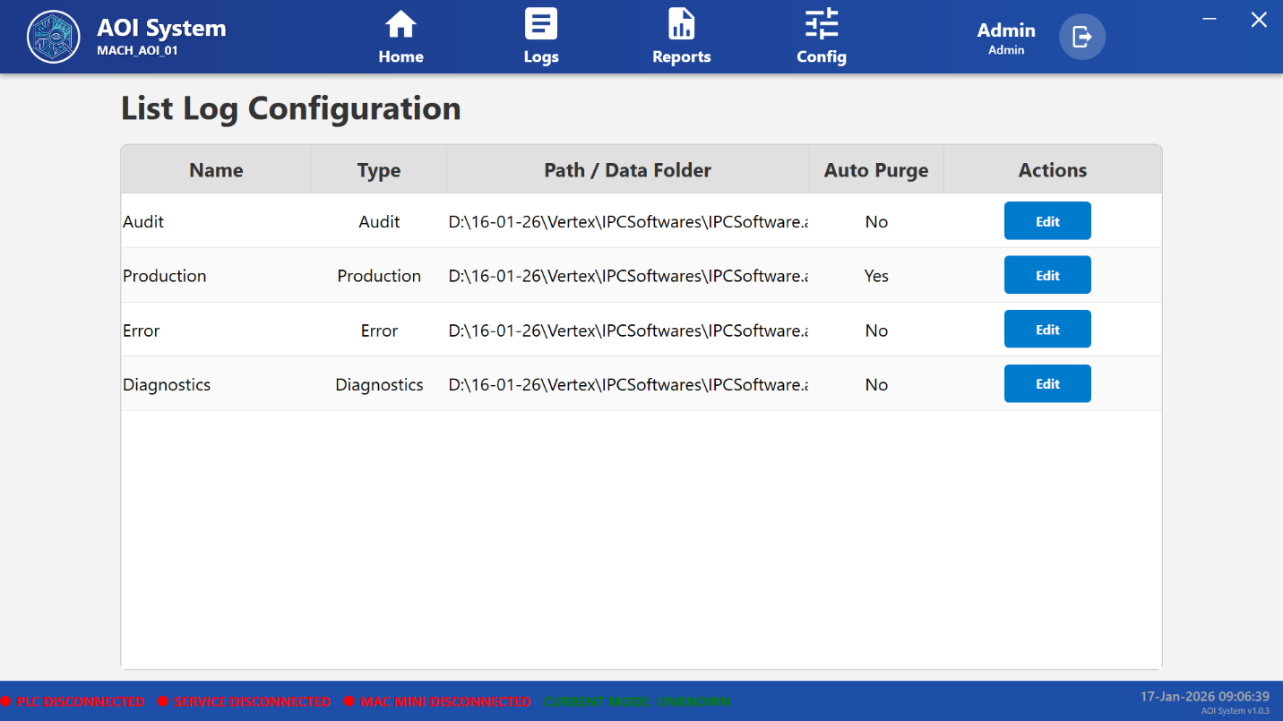

### **30.4 Log Configuration Table Description**

The Log Configuration table contains the following columns:

#### **30.4.1 Name**

Displays the name of the log category.  
Example:

* Audit
* Production
* Error
* Diagnostics

#### **30.4.2 Type**

Indicates the type of log data generated by the system.  
Each type corresponds to a specific system activity or event category.

#### **30.4.3 Path / Data Folder**

Shows the directory path where the log files are stored on the system.  
This path defines the physical storage location for log data.

#### **30.4.4 Auto Purge**

Indicates whether automatic deletion of old log files is enabled.

* **Yes** – Old log files are automatically removed based on system rules
* **No** – Log files are retained until manually removed

#### **30.4.5 Actions**

Provides control options for modifying log configuration settings.  
The **Edit** button allows authorized users to update log-related parameters.

### **30.5 Available Log Types**

The system supports the following log categories:

#### **30.5.1 Audit Log**

Records user login, logout, and configuration-related activities for traceability and security auditing.

#### **30.5.2 Production Log**

Stores production-related events and inspection process information generated during system operation.

#### **30.5.3 Error Log**

Captures system errors, failures, and abnormal conditions that require attention.

#### **30.5.4 Diagnostics Log**

Records diagnostic and system health information used for troubleshooting and analysis.

### **30.6 Operator / Administrator Guidelines**

* Log configuration should be modified only by authorized personnel
* Incorrect log settings may affect system traceability
* Auto Purge settings should be reviewed carefully before enabling
* Log files are critical for troubleshooting and compliance purposes

### **30.7 Important Notes**

* Operators typically have view-only or no access to Log Configuration
* Administrative privileges are required to edit log settings
* Log storage paths should not be changed without system validation
* Deleting or mismanaging logs may result in loss of diagnostic data

## **31 Device Configuration**

### **31.1 Screen Name**

Device Configuration

### **31.2 Purpose**

The Device Configuration screen is used to define, manage, and maintain the details of hardware devices connected to the AOI system.  
This configuration ensures proper identification and integration of all system components such as controllers, vision devices, and peripheral equipment.

### **31.3 Screen Overview**

When the user selects **Device Config** from the Configuration menu, the system displays a tabular list of configured devices.

This screen allows authorized users to:

* View existing device configurations
* Add new devices
* Edit device-related information

Access to this screen is restricted to **Admin users only**.

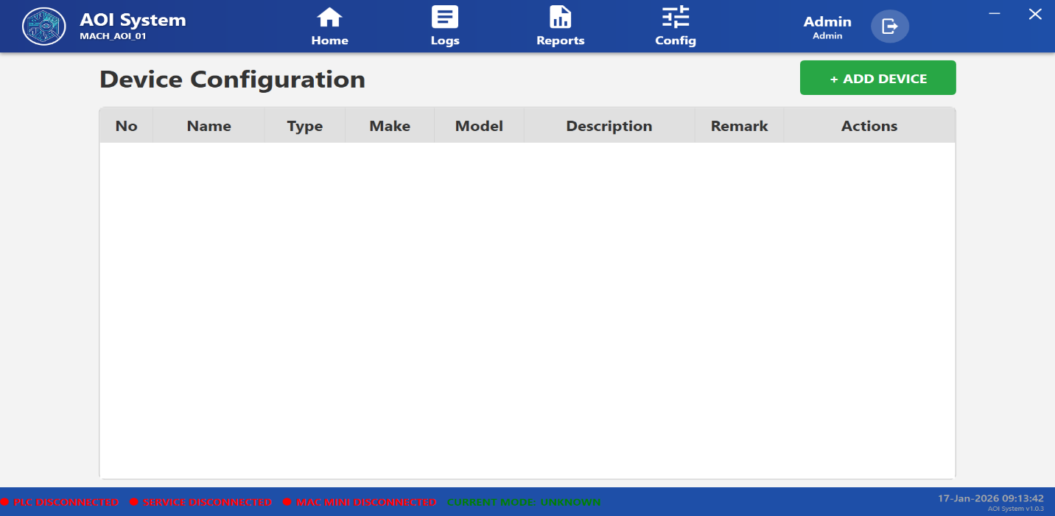

### **31.4 Device Configuration Table Description**

The Device Configuration table contains the following columns:

#### **31.4.1 No**

Displays the serial number of the device entry.

#### **31.4.2 Name**

Indicates the logical name assigned to the device for identification within the system.

#### **31.4.3 Type**

Specifies the category or role of the device.  
Example:

* PLC
* Vision System
* Controller
* Peripheral Device

#### **31.4.4 Make**

Displays the manufacturer of the device.

#### **31.4.5 Model**

Shows the model number or model name of the device.

#### **31.4.6 Description**

Provides a brief description of the device purpose or functionality.

#### **31.4.7 Remark**

Displays additional notes or comments related to the device configuration.

#### **31.4.8 Actions**

Provides action controls for managing device entries.  
Typical actions include:

* Edit device details
* Update configuration parameters

### **31.5 Add Device Function**

The **+ Add Device** button allows administrators to register a new device into the AOI system.

Using this function, the user can:

* Define device identity details
* Specify device type and model information
* Save the device configuration for system use

### **31.6 Operator / Administrator Guidelines**

* Device configuration should be performed only by authorized administrators
* Incorrect device information may cause communication or operational issues
* Device details must match actual hardware specifications
* Changes should be verified before starting production

### **31.7 Important Notes**

* Operators do not have permission to add or modify devices
* Device configuration directly impacts system communication and stability
* Any changes to device settings should be documented and approved
* Device removal or modification should be done during system downtime

## **32 Alarm Configuration**

### **32.1 Screen Name**

Alarm Configuration

### **32.2 Purpose**

The Alarm Configuration screen is used to define, manage, and maintain alarm conditions generated by the AOI system.  
This screen allows administrators to configure alarm messages, severity levels, and PLC tag associations to ensure timely notification of system faults or abnormal conditions.

### **32.3 Screen Overview**

When the user selects **Alarm Config** from the Configuration menu, the system displays a list of configured alarms in a tabular format.

This screen provides options to:

* View existing alarm configurations
* Add new alarm definitions
* Modify alarm details

Access to this screen is restricted to **Admin users only.**

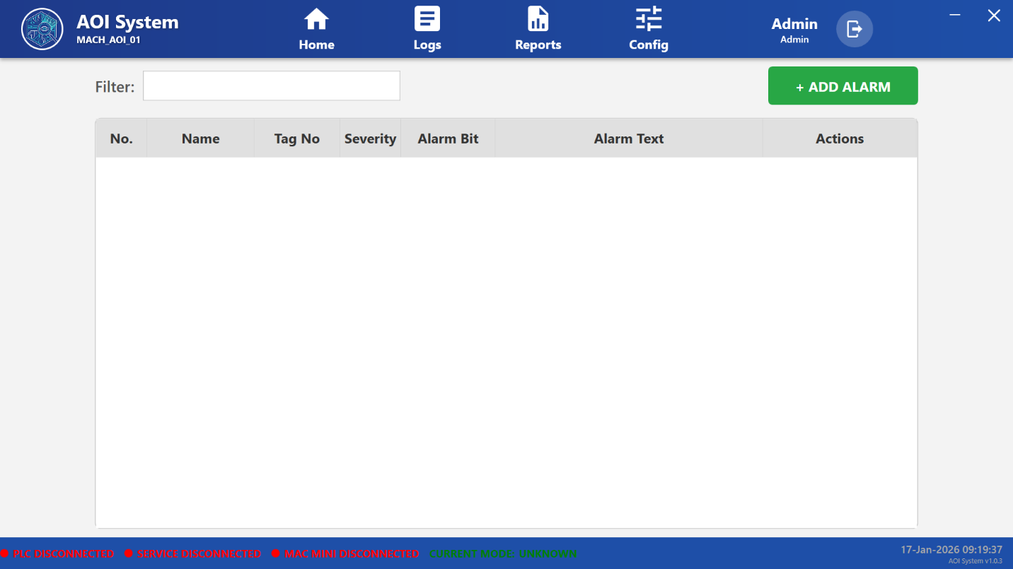

### **32.4 Alarm Configuration Table Description**

The Alarm Configuration table consists of the following columns:

#### **32.4.1 No**

Displays the serial number of the alarm entry.

#### **32.4.2 Name**

Specifies the logical name of the alarm for identification purposes.

#### **32.4.3 Tag No**

Indicates the PLC tag number associated with the alarm condition.  
This tag is monitored by the system to detect alarm states.

#### **32.4.4 Severity**

Defines the priority level of the alarm.  
Severity levels help operators understand the criticality of the alarm.

Examples:

* Low
* Medium
* High

#### **32.4.5 Alarm Bit**

Represents the specific bit position within the PLC tag that triggers the alarm.

#### **32.4.6 Alarm Text**

Displays the descriptive message shown to the operator when the alarm is activated.  
This text should clearly describe the fault or abnormal condition.

#### **32.4.7 Actions**

Provides control options for managing alarm entries, such as:

* Edit alarm configuration
* Update alarm parameters

### **32.5 Filter Function**

The **Filter** field allows administrators to quickly search and locate specific alarms based on name, tag number, or alarm text.

### **32.6 Add Alarm Function**

The **+ Add Alarm** button allows administrators to create a new alarm entry.

Using this function, the user can:

* Assign PLC tag and alarm bit
* Define alarm severity
* Configure operator-visible alarm text

### **32.7 Operator / Administrator Guidelines**

* Alarm configuration should be performed only by authorized personnel
* Alarm text should be clear and meaningful for operators
* Severity levels must be assigned correctly to avoid confusion
* Any changes should be validated before production use

### **32.8 Important Notes**

* Operators cannot add or modify alarm configurations
* Incorrect alarm mapping may result in missed or false alarms
* Alarm configuration directly affects system safety and reliability
* Changes should be documented and approved as per site procedure

## **33 User Configuration (User Management)**

### **33.1 Screen Name**

User Management

### **33.2 Purpose**

The User Management screen is used to create, modify, activate, or deactivate user accounts for accessing the AOI system.  
This screen ensures role-based access control so that users can only access features permitted by their assigned role.

### **33.3 Screen Overview**

When **User Config** is selected from the Configuration menu, the system displays a list of all configured users in a tabular format.

This screen allows administrators to:

* View existing users
* Add new users
* Edit user details
* Delete user accounts

Access to this screen is restricted to **Admin users only.**

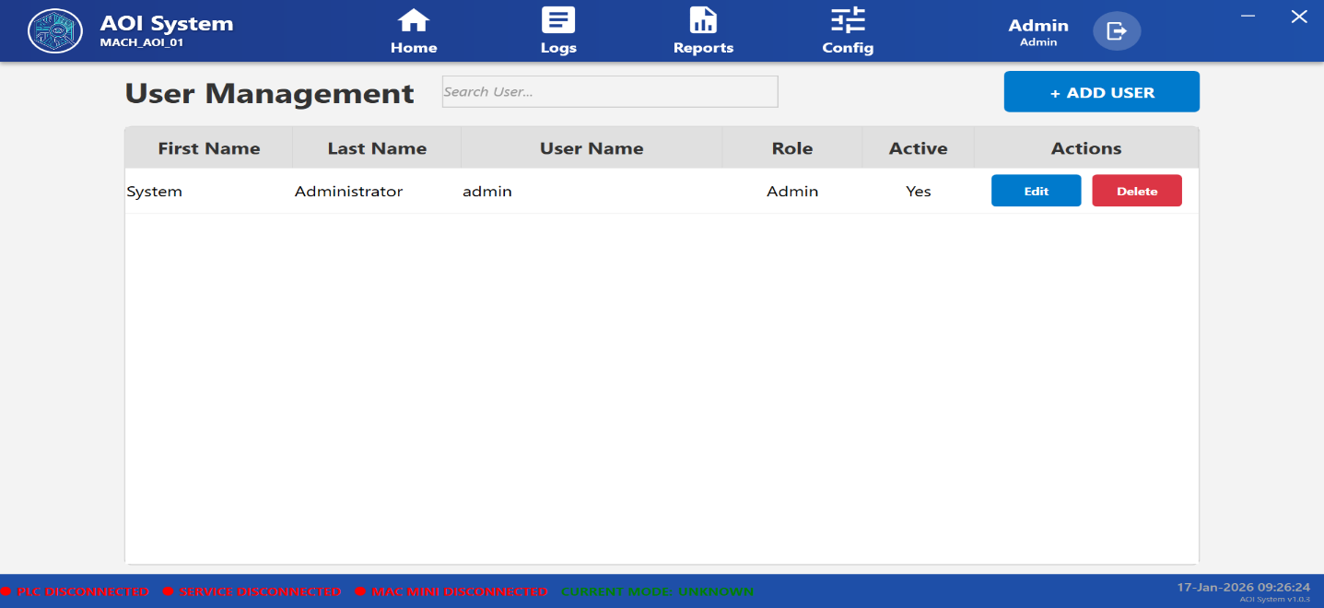

### **33.4 User List Table Description**

The User Management table consists of the following columns:

#### **33.4.1 First Name**

Displays the first name of the user.

#### **33.4.2 Last Name**

Displays the last name of the user.

#### **33.4.2 Last Name**

Displays the last name of the user.

#### **33.4.4 Role**

Indicates the assigned role of the user, which defines access permissions.

Typical roles include:

* Admin
* Operator

#### **33.4.5 Active**

Shows whether the user account is currently active.

Values:

* Yes – User is allowed to log in
* No – User login is disabled

#### **33.4.6 Actions**

Provides control options for managing user accounts:

* **Edit** – Modify user details or role
* **Delete** – Remove the user account from the system

### **33.5 Search User Function**

The **Search User** field allows administrators to quickly locate users by username, first name, or last name.

### **33.6 Add User Function**

The **+ Add User** button is used to create a new user account.

Using this function, administrators can:

* Define user name and personal details
* Assign user role
* Enable or disable account access

### **33.7 Operator / Administrator Guidelines**

* Only Admin users are authorized to manage user accounts
* Each user must have a unique username
* User roles must be assigned carefully to prevent unauthorized access
* Deactivated users cannot log in to the system

### **33.8 Important Notes**

* Operators cannot create, edit, or delete user accounts
* Deleting a user may affect traceability in audit logs
* User management directly impacts system security
* All changes should follow company access control policies

## **34 PLC Tag Configuration**

### **34.1 Screen Name**

PLC Tag Configuration

### **34.2 Purpose**

The PLC Tag Configuration screen is used to define and manage PLC tags that enable communication between the AOI system and the PLC.  
These tags are used for reading and writing process signals required for machine operation, inspection control, and status monitoring.

### **34.3 Screen Overview**

When **PLC TAG Config** is selected from the Configuration menu, the system displays a table listing all configured PLC tags.

This screen allows authorized users to:

* View existing PLC tags
* Add new PLC tags
* Edit tag parameters
* Manage PLC data mapping

This configuration directly affects system-PLC communication.

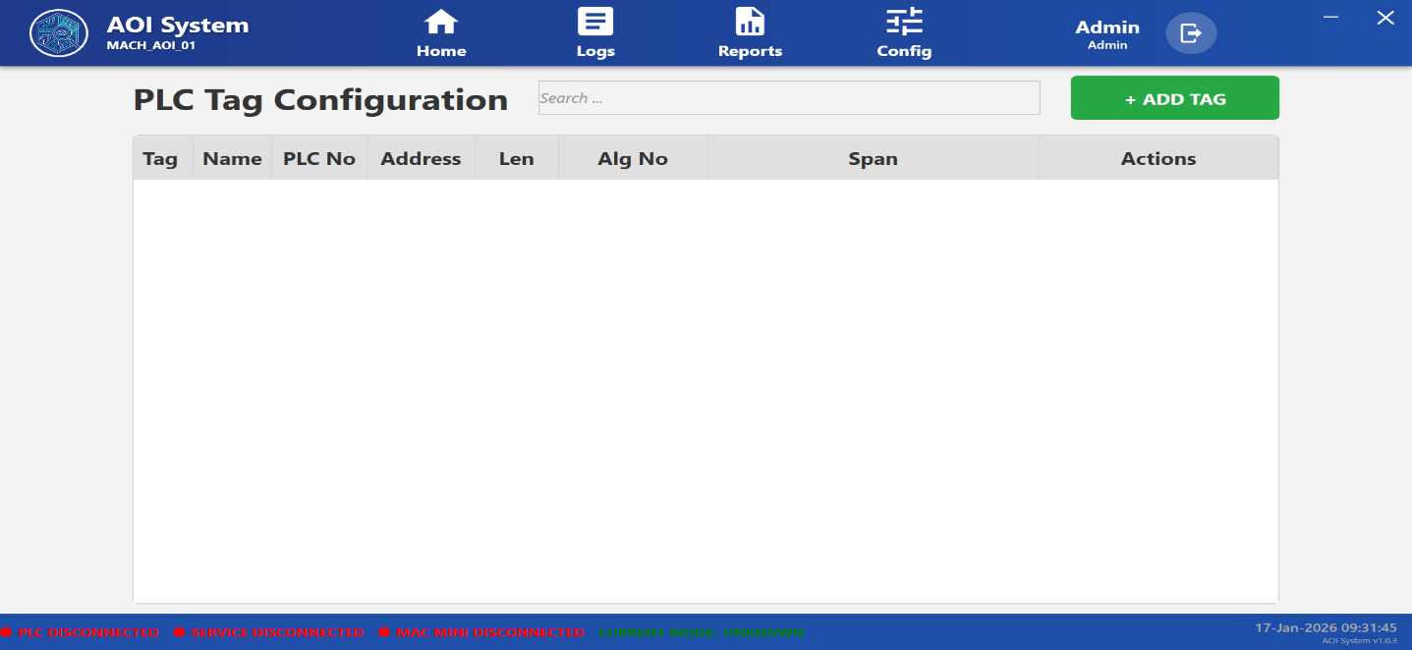

### **34.4 PLC Tag List Table Description**

The PLC Tag Configuration table contains the following columns:

#### **34.4.1 Tag**

Displays the unique tag identifier used internally by the system.

#### **34.4.2 Name**

Shows the logical name of the PLC tag representing a specific signal or function.

#### **34.4.3 PLC No**

Indicates the PLC number to which the tag belongs (used in multi-PLC systems).

#### **34.4.4 Address**

Displays the PLC memory address associated with the tag.

#### **34.4.5 Len (Length)**

Specifies the data length of the PLC tag.

#### **34.4.6 Alg No (Algorithm Number)**

Indicates the algorithm or logic reference linked with the PLC tag, if applicable.

#### **34.4.7 Span**

Defines the scaling or span range used for the PLC data value.

#### **34.4.8 Actions**

Provides options to manage PLC tags:

* **Edit** – Modify existing PLC tag parameters

### **34.5 Search Function**

The **Search** field allows users to quickly find PLC tags by tag name or address.

### **34.6 Add Tag Function**

The **+ Add Tag** button is used to create a new PLC tag configuration.

Using this function, users can:

* Assign tag name and PLC number
* Define PLC address and data length
* Configure algorithm and span values

### **34.6 Add Tag Function**

The **+ Add Tag** button is used to create a new PLC tag configuration.

Using this function, users can:

* Assign tag name and PLC number
* Define PLC address and data length
* Configure algorithm and span values

### **34.8 Important Notes**

* PLC Tag Configuration is critical for system-PLC communication
* Any modification may impact machine operation and inspection logic
* Configuration changes should follow approved engineering procedures
* Backup of PLC tag settings is recommended before modification

## **35 Shift Configuration**

### **35.1 Screen Name**

Shift Configuration

### **35.2 Purpose**

The Shift Configuration screen is used to define and manage production shifts within the AOI system.  
Configured shifts are used for organizing production data, reports, and operational statistics based on time intervals.

### **35.3 Screen Overview**

When **Shift Config** is selected from the Configuration menu, the system displays the Shift Configuration screen.

This screen is divided into two main sections:

* Shift List Table (left side)
* Shift Details Panel (right side)

The screen allows authorized users to create, modify, activate, or deactivate production shifts.

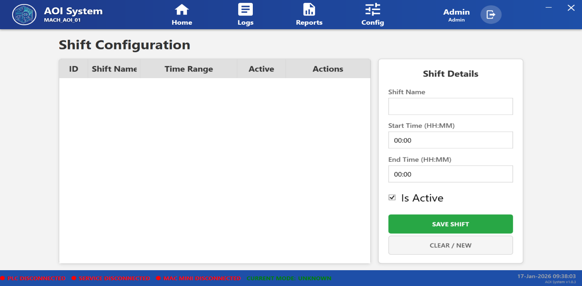

### **35.4 Shift List Table Description**

The Shift List table displays all configured shifts with the following columns:

#### **35.4.1 ID**

Displays the unique identification number of the shift.

#### **35.4.2 Shift Name**

Shows the name assigned to the shift (for example: Shift A, Shift B, Night Shift).

#### **35.4.3 Time Range**

Displays the configured start time and end time of the shift.

#### **35.4.4 Active**

Indicates whether the shift is currently active or inactive.

#### **35.4.5 Actions**

Provides options to manage shift records:

* Select a shift for editing

### **35.5 Shift Details Panel**

The Shift Details panel is used to add or edit shift information.

It includes the following fields:

#### **35.5.1 Shift Name**

Allows the user to enter or modify the name of the shift.

### **35.5 Shift Details Panel**

The Shift Details panel is used to add or edit shift information.

It includes the following fields:

#### **35.5.1 Shift Name**

Allows the user to enter or modify the name of the shift.

#### **35.5.3 End Time (HH:MM)**

Defines the end time of the shift in hours and minutes.

#### **35.5.4 Is Active**

Checkbox used to enable or disable the shift.

#### **35.5.5 Save Shift**

The **Save Shift** button is used to save the configured shift details.

#### **35.5.6 Clear / New**

The **Clear / New** button clears the current input fields to create a new shift configuration.

### **35.7 Important Notes**

* Shift Configuration directly impacts production reports and data segregation
* Shift changes should be planned and approved before implementation
* Incorrect shift timing may lead to inaccurate production data
* Only authorized users should modify shift settings

## **36 Report Configuration**

### **36.1 Screen Name**

Report Format Configuration

### **36.2 Purpose**

The Report Configuration screen is used to create, edit, and manage custom report formats.  
It allows users to define which data columns should be included in production reports generated by the AOI system.

### **36.3 Screen Overview**

When **Report Config** is selected from the Configuration menu, the **Report Format Configuration** screen is displayed.

This screen is divided into three main sections:

1. Saved Report Formats
2. Report Details
3. Selected Columns

The screen enables users to design report structures without affecting live production data.

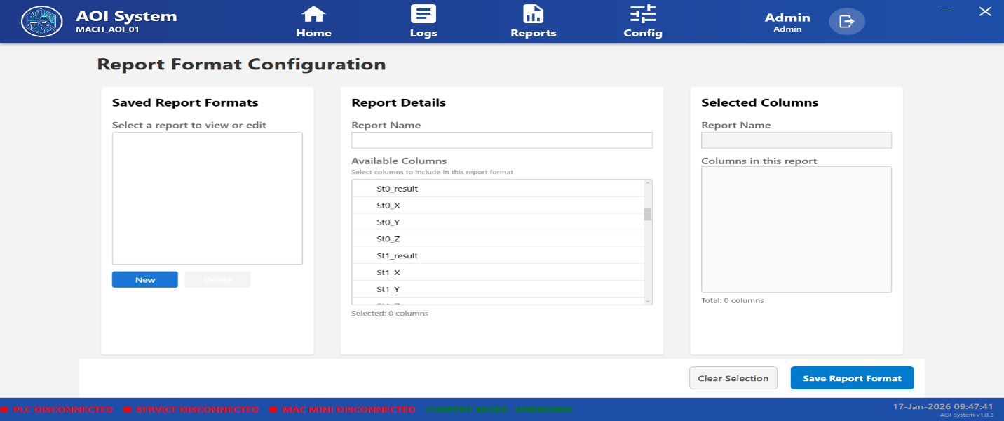

### **36.4 Saved Report Formats Section**

#### **36.4.1 Description**

This section displays a list of previously saved report formats.

#### **36.4.2 Functions**

* Select an existing report format to view or edit
* Create a new report format
* Delete an existing report format (if permitted)

#### **36.4.3 Controls**

* **New**: Creates a new report format
* **Delete**: Removes the selected report format

### **36.5 Report Details Section**

#### **36.5.1 Report Name**

Allows the user to enter or modify the name of the report format.

#### **36.5.2 Available Columns**

Displays a list of all available data columns that can be included in the report.

Examples of available columns may include:

* Station results
* Measurement values (X, Y, Z)
* Inspection outcomes
* Process-related parameters

(Actual column names depend on system configuration.)

#### **36.5.3 Column Selection**

Users can select required columns from the Available Columns list to include them in the report format.

### **36.6 Selected Columns Section**

#### **36.6.1 Description**

This section displays the columns that are selected for the current report format.

#### **36.6.2 Functions**

* Review selected report columns
* Verify column count for the report

#### **36.6.3 Column Count**

Displays the total number of columns included in the report format.

### **36.7 Action Buttons**

#### **36.7.1 Clear Selection**

Clears all selected columns from the report format.

#### **36.7.2 Save Report Format**

Saves the report format with the selected columns and report name.

### **36.8 Operator / Administrator Guidelines**

* Report configuration defines report structure only
* Report configuration does not modify actual production data
* Select only required columns to keep reports clean and readable
* Use meaningful report names for easy identification

### **36.9 Important Notes**

* Report formats are used during report generation and export
* Incorrect column selection may result in incomplete reports
* Only authorized users should modify report configurations
* Changes apply only to newly generated reports

## **37 Servo Parameters**

### **37.1 Screen Name**

Servo Parameters

### **37.2 Purpose**

The Servo Parameters screen is used to configure and fine-tune the motion control parameters of the servo axes used in the AOI system.  
These parameters define how the X and Y axes move during manual jogging, automatic operation, and positioning tasks.

### **37.3 Screen Overview**

The Servo Parameters screen consists of two main sections:

* **X-Axis Parameters**
* **Y-Axis Parameters**

Each section displays current parameter values along with input fields to set new values.  
A common **SAVE** button is provided to permanently store the updated servo parameters.

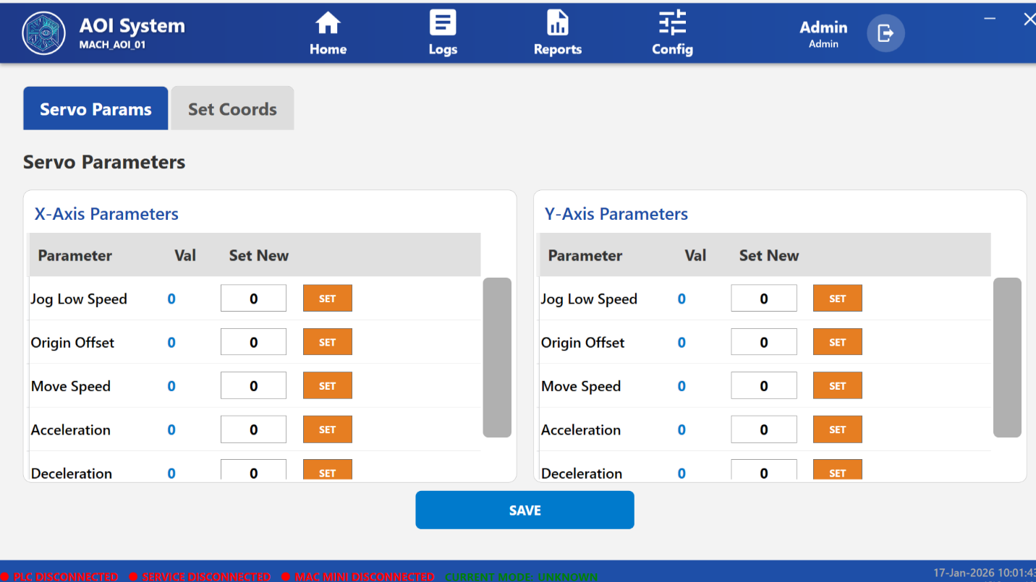

### **37.4 X-Axis Parameters**

This section allows configuration of motion parameters related to the **X-axis servo**.

The following parameters are available:

* **Jog Low Speed**  
  Defines the slow movement speed used for precise jogging of the X-axis.
* **Origin Offset**  
  Specifies the offset value applied to the X-axis origin reference point.
* **Move Speed**  
  Defines the normal operating movement speed of the X-axis during automatic operation.
* **Acceleration**  
  Controls the rate at which the X-axis accelerates to the set speed.
* **Deceleration**  
  Controls the rate at which the X-axis slows down and stops.

Each parameter includes:

* Current value display (**Val**)
* Input field to enter a new value (**Set New**)
* **SET** button to apply the value

### **37.5 Y-Axis Parameters**

This section allows configuration of motion parameters related to the **Y-axis servo**.

The following parameters are available:

* **Jog Low Speed**  
  Defines the slow movement speed used for Y-axis jogging operations.
* **Origin Offset**  
  Specifies the offset value applied to the Y-axis origin reference.
* **Move Speed**  
  Defines the normal operating movement speed of the Y-axis.
* **Acceleration**  
  Controls how quickly the Y-axis reaches the configured movement speed.
* **Deceleration**  
  Controls how smoothly the Y-axis comes to a stop.

Each parameter includes:

* Current value display (**Val**)
* Input field to enter a new value (**Set New**)
* **SET** button to apply the value

### **37.6 Parameter Update Procedure**

The servo parameter update procedure is as follows:

1. Enter a new value in the **Set New** input field.
2. Click the **SET** button for the respective parameter.
3. The value is updated temporarily.
4. Click the **SAVE** button to permanently store all changes.

### **37.7 Operator Actions**

The operator can perform the following actions on this screen:

* View current servo parameter values
* Modify motion-related parameters
* Apply changes using individual **SET** buttons
* Save all updated parameters using the **SAVE** button

### **37.8 Operator Guidelines**

* Modify servo parameters only if authorized and trained.
* Incorrect values may result in unsafe or unstable machine motion.
* Always verify axis movement after changing speed or acceleration settings.
* Use low jog speeds during manual setup and teaching operations.

### **37.9 Important Notes**

* Servo parameter changes directly affect machine motion behavior.
* Values should be configured according to machine and servo specifications.
* Changes take effect immediately after saving.
* Improper settings may impact machine accuracy, safety, and component life.

## **38. Set Coords (Position Teaching)**

### **38.1 Screen Name**

Set Coords / Position Teaching

### **38.2 Purpose**

The Set Coords screen is used to **teach and store predefined servo positions** for machine operation.  
These positions are used during automatic sequences and inspection processes.

### **38.3 Screen Overview**

This screen displays:

* Live X and Y axis position values
* A list of predefined positions
* Jog control buttons for manual movement
* Teach and Write options for saving coordinates

The screen helps the operator accurately define machine positions.

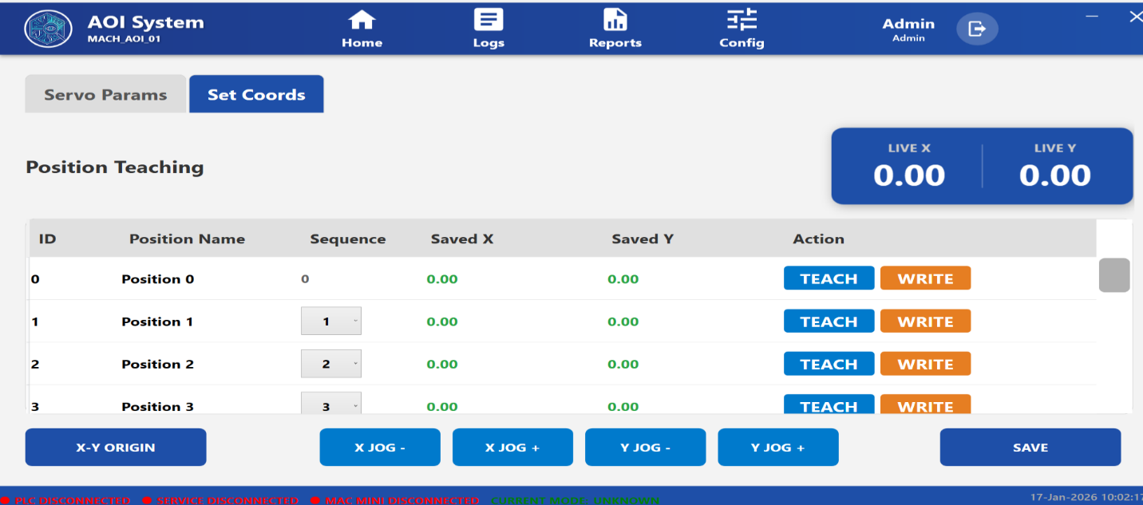

### **38.4 Displayed Information**

The following information is displayed in tabular form:

* Position ID
* Position Name
* Sequence number
* Saved X coordinate
* Saved Y coordinate
* Action buttons

Live position indicators show:

* **Live X position**
* **Live Y position**

### **38.5 Operator Actions**

The operator can:

* Jog X and Y axes using jog buttons
* Set machine origin using **X-Y ORIGIN**
* Teach current position using **TEACH**
* Save taught position to PLC using **WRITE**
* Arrange operation order using Sequence number
* Save all changes using **SAVE** button

### **38.6 Jog Controls**

Available jog controls:

* X JOG +
* X JOG −
* Y JOG +
* Y JOG −

These controls allow fine positioning during teaching.

### **38.7 Teaching Procedure**

1. Jog the machine to the desired position
2. Verify Live X and Y values
3. Click **TEACH** to capture the position
4. Click **WRITE** to store the position
5. Repeat for other positions
6. Click **SAVE** to finalize changes

### **38.8 Operator Guidelines**

* Use low jog speed while teaching positions
* Ensure machine is in safe condition before jogging
* Verify saved coordinates after writing
* Do not overwrite positions without confirmation

### **38.9 Important Notes**

* Taught positions are critical for machine accuracy
* Incorrect coordinates may cause collision or misalignment
* Only trained operators should perform position teaching

## **39 Time Sync (System Synchronization)**

### **39.1 Screen Name**

System Synchronization (Time Sync)

### **39.2 Purpose**

The Time Sync screen is used to synchronize the system date and time between the IPC and the PLC.  
This ensures accurate timestamping of logs, alarms, reports, and audit trail records.

### **39.3 Screen Overview**

The screen displays:

* Current IPC date and time
* Current PLC date and time
* A SYNC button to synchronize time
* An Audit Trail Log section

This screen allows authorized users to maintain time consistency across the system.

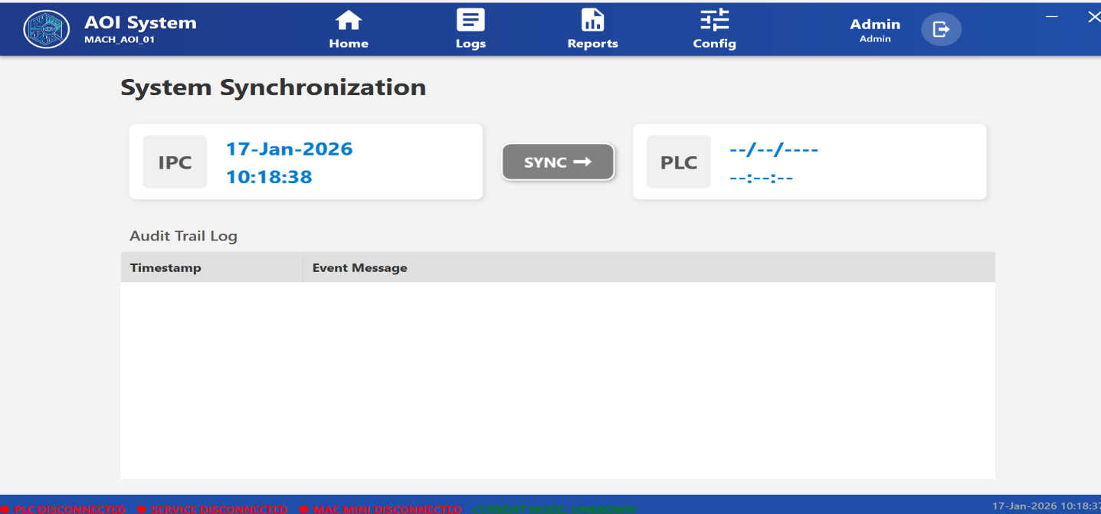

### **39.4 Displayed Information**

#### **IPC Time**

* Current date
* Current time of the IPC

#### **PLC Time**

* Date stored in the PLC
* Time stored in the PLC

#### **Audit Trail Log**

The audit log table displays:

* Timestamp
* Event Message related to time synchronization

### **39.5 Operator Actions**

The operator can:

* View current IPC and PLC time
* Click **SYNC** to update PLC time using IPC time
* Review synchronization history in the Audit Trail Log

### **39.6 Synchronization Process**

1. Verify IPC date and time
2. Check PLC date and time
3. Click the **SYNC** button
4. System updates PLC time to match IPC time
5. Synchronization event is recorded in Audit Trail Log

### **39.7 Operator Guidelines**

* Ensure IPC time is correct before synchronization
* Perform time sync during idle or safe machine condition
* Use this function only when authorized

### **39.8 Important Notes**

* Incorrect system time may affect logs, reports, and traceability
* Time synchronization does not interrupt machine operation
* All synchronization actions are logged for audit purposes

**40 Diagnostic**

### **40.1 Screen Name**

Diagnostic

### **40.2 Purpose**

The Diagnostic screen is used to monitor PLC tag values in real time and, if authorized, manually write values to specific PLC tags for testing, troubleshooting, and maintenance purposes.

This screen helps engineers and maintenance personnel to verify PLC communication and diagnose system-level issues.

### **40.3 Screen Overview**

The Diagnostic screen displays a tabular list of PLC tags along with their current values and write options.  
A search option is provided to quickly locate specific tags.

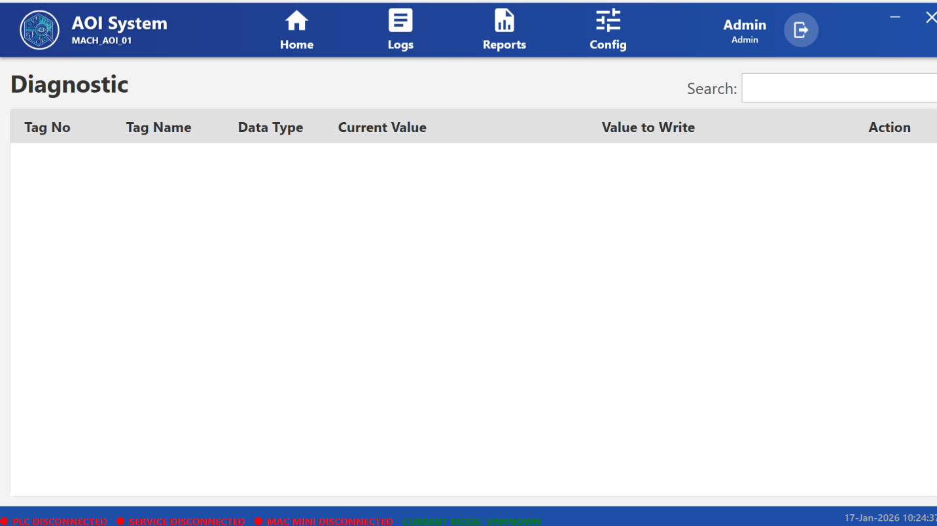

### **40.4 Displayed Information**

The Diagnostic table includes the following columns:

* **Tag No**  
  Unique identification number of the PLC tag.
* **Tag Name**  
  Logical name of the PLC tag used within the system.
* **Data Type**  
  Data type of the PLC tag (e.g., BOOL, INT, REAL).
* **Current Value**  
  Live value currently read from the PLC.
* **Value to Write**  
  Input field to enter a new value for the selected tag.
* **Action**  
  Option to write the entered value to the PLC.

### **40.5 Operator Actions**

The operator can:

* Search for a PLC tag using the search box
* View live PLC tag values
* Enter a new value in the “Value to Write” field
* Write the value to the PLC using the Action control (if permitted)

### **40.6 Usage Guidelines**

* Use this screen only for testing and diagnostic purposes
* Ensure correct data type before writing any value
* Incorrect values may affect machine behavior

### **40.7 Operator Access Control**

* This screen is typically restricted to authorized users
* Writing PLC values may require administrative or engineering privileges

### **40.8 Important Notes**

* Diagnostic operations should be performed when the machine is in a safe state
* Writing incorrect PLC values may cause unexpected system behavior
* All diagnostic activities depend on active PLC communication

**41 MacMini Test**

### **41.1 Screen Name**

MacMini Test (API Test Console)

### **41.2 Purpose**

The MacMini Test screen is used to test and verify API communication between the AOI system and the Mac Mini or external system.  
This screen allows users to manually trigger API requests and observe responses for integration validation and troubleshooting.

### **41.3 Screen Overview**

The MacMini Test screen provides an interactive console where API request parameters can be entered and tested.  
It includes input fields for request configuration and a response panel to display API results.

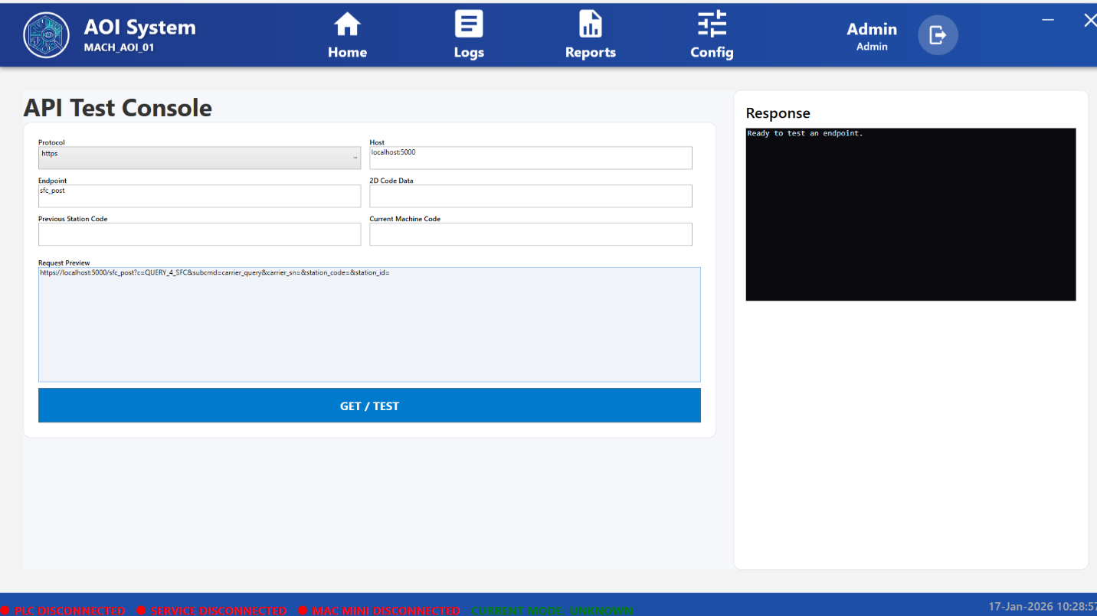

### **41.4 Input Fields Description**

The following input fields are available on this screen:

* **Protocol**  
  Selects the communication protocol (e.g., HTTP / HTTPS).
* **Host**  
  Specifies the server address and port of the target system (e.g., localhost:5000).
* **Endpoint**  
  Defines the API endpoint to be tested.
* **2D Code Data**  
  Input field for scanned or manually entered 2D code data.
* **Previous Station Code**  
  Represents the station code from the previous process or machine.
* **Current Machine Code**  
  Represents the current machine or station identifier.
* **Request Preview**  
  Displays the complete generated API request URL based on the entered parameters.

### **41.5 Response Panel**

* Displays the response received from the API after execution
* Shows success messages, error messages, or returned data
* Used to verify API connectivity and data exchange

### **41.6 Operator Actions**

The operator can:

* Configure API request parameters
* Review the generated request in the preview section
* Click **GET / TEST** to send the API request
* Observe and analyze the response in the response panel

### **41.7 Usage Guidelines**

* Use this screen primarily for testing and validation
* Ensure correct endpoint and parameters before testing
* Invalid inputs may result in error responses

### **41.8 Operator Access Control**

* Typically accessible to engineers or administrators
* Not intended for routine production operation

### **41.9 Important Notes**

* This screen does not affect live inspection unless explicitly integrated
* API responses depend on network connectivity and external system availability
* Use this feature only when the system is in a safe and controlled state